My Bucket of Favourite Things
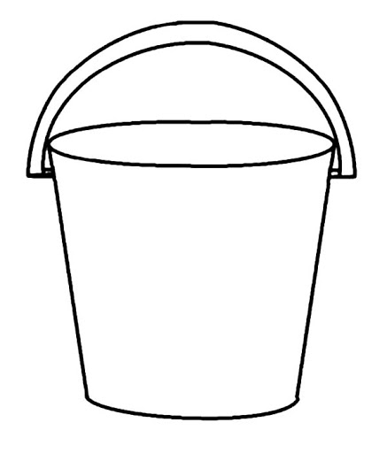
Harry kept his favourite toys, his dinosaurs, inside a bucket. Fill this bucket with pictures of your favourite things. You can use photographs or draw pictures.

