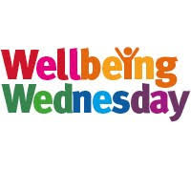  EYFS/ KS1  10/2/21 | Play with Lego and build a model. | Colour a mindfulness picture (in your wellbeing pack). | Draw with Rob or paint a picture.  http://www.robbiddulph.com/draw-with-rob
Enjoy a hot chocolate and a biscuit from your wellbeing pack (ask an adult to make it for you). | Build a den. | Do some baking with an adult. | Take part in cosmic yoga  https://cosmickids.com/watch/
Go on a walk/ nature trail in your local area. | Read your favourite story book. | Listen to some music and have a dance. | Play a board game.
Make a card or a picture for a friend. | Watch a movie. | Catch up with your friends on the class Zoom call. | Have a bubble bath before bed.

