5th January 2021

Dear Parents/Carers,

Due to the announcement from Government last night, you will be aware the situation has changed and we are in a National Lockdown.

Our number of Keyworker and Vulnerable Children is higher than we expected and following on from the Prime Minister’s address last night we ask that if you do not need a Key Worker place, you allow your child to work remotely from home.

To ensure that Teachers have time to plan together and to have a deep clean of the building, we will be closing every Friday afternoon from January 8th. Pick up times are as follows….

Y6 – 1.00pm
Y5 – 1.05pm
Y4 – 1.10pm
Y3 – 1.15pm

KS1/EYFS – Gates are open from 12.55pm.

Thank you for all your support at this difficult time.

Take care and stay safe.

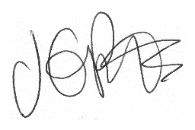

Jacqui Potts
Headteacher

