Caption

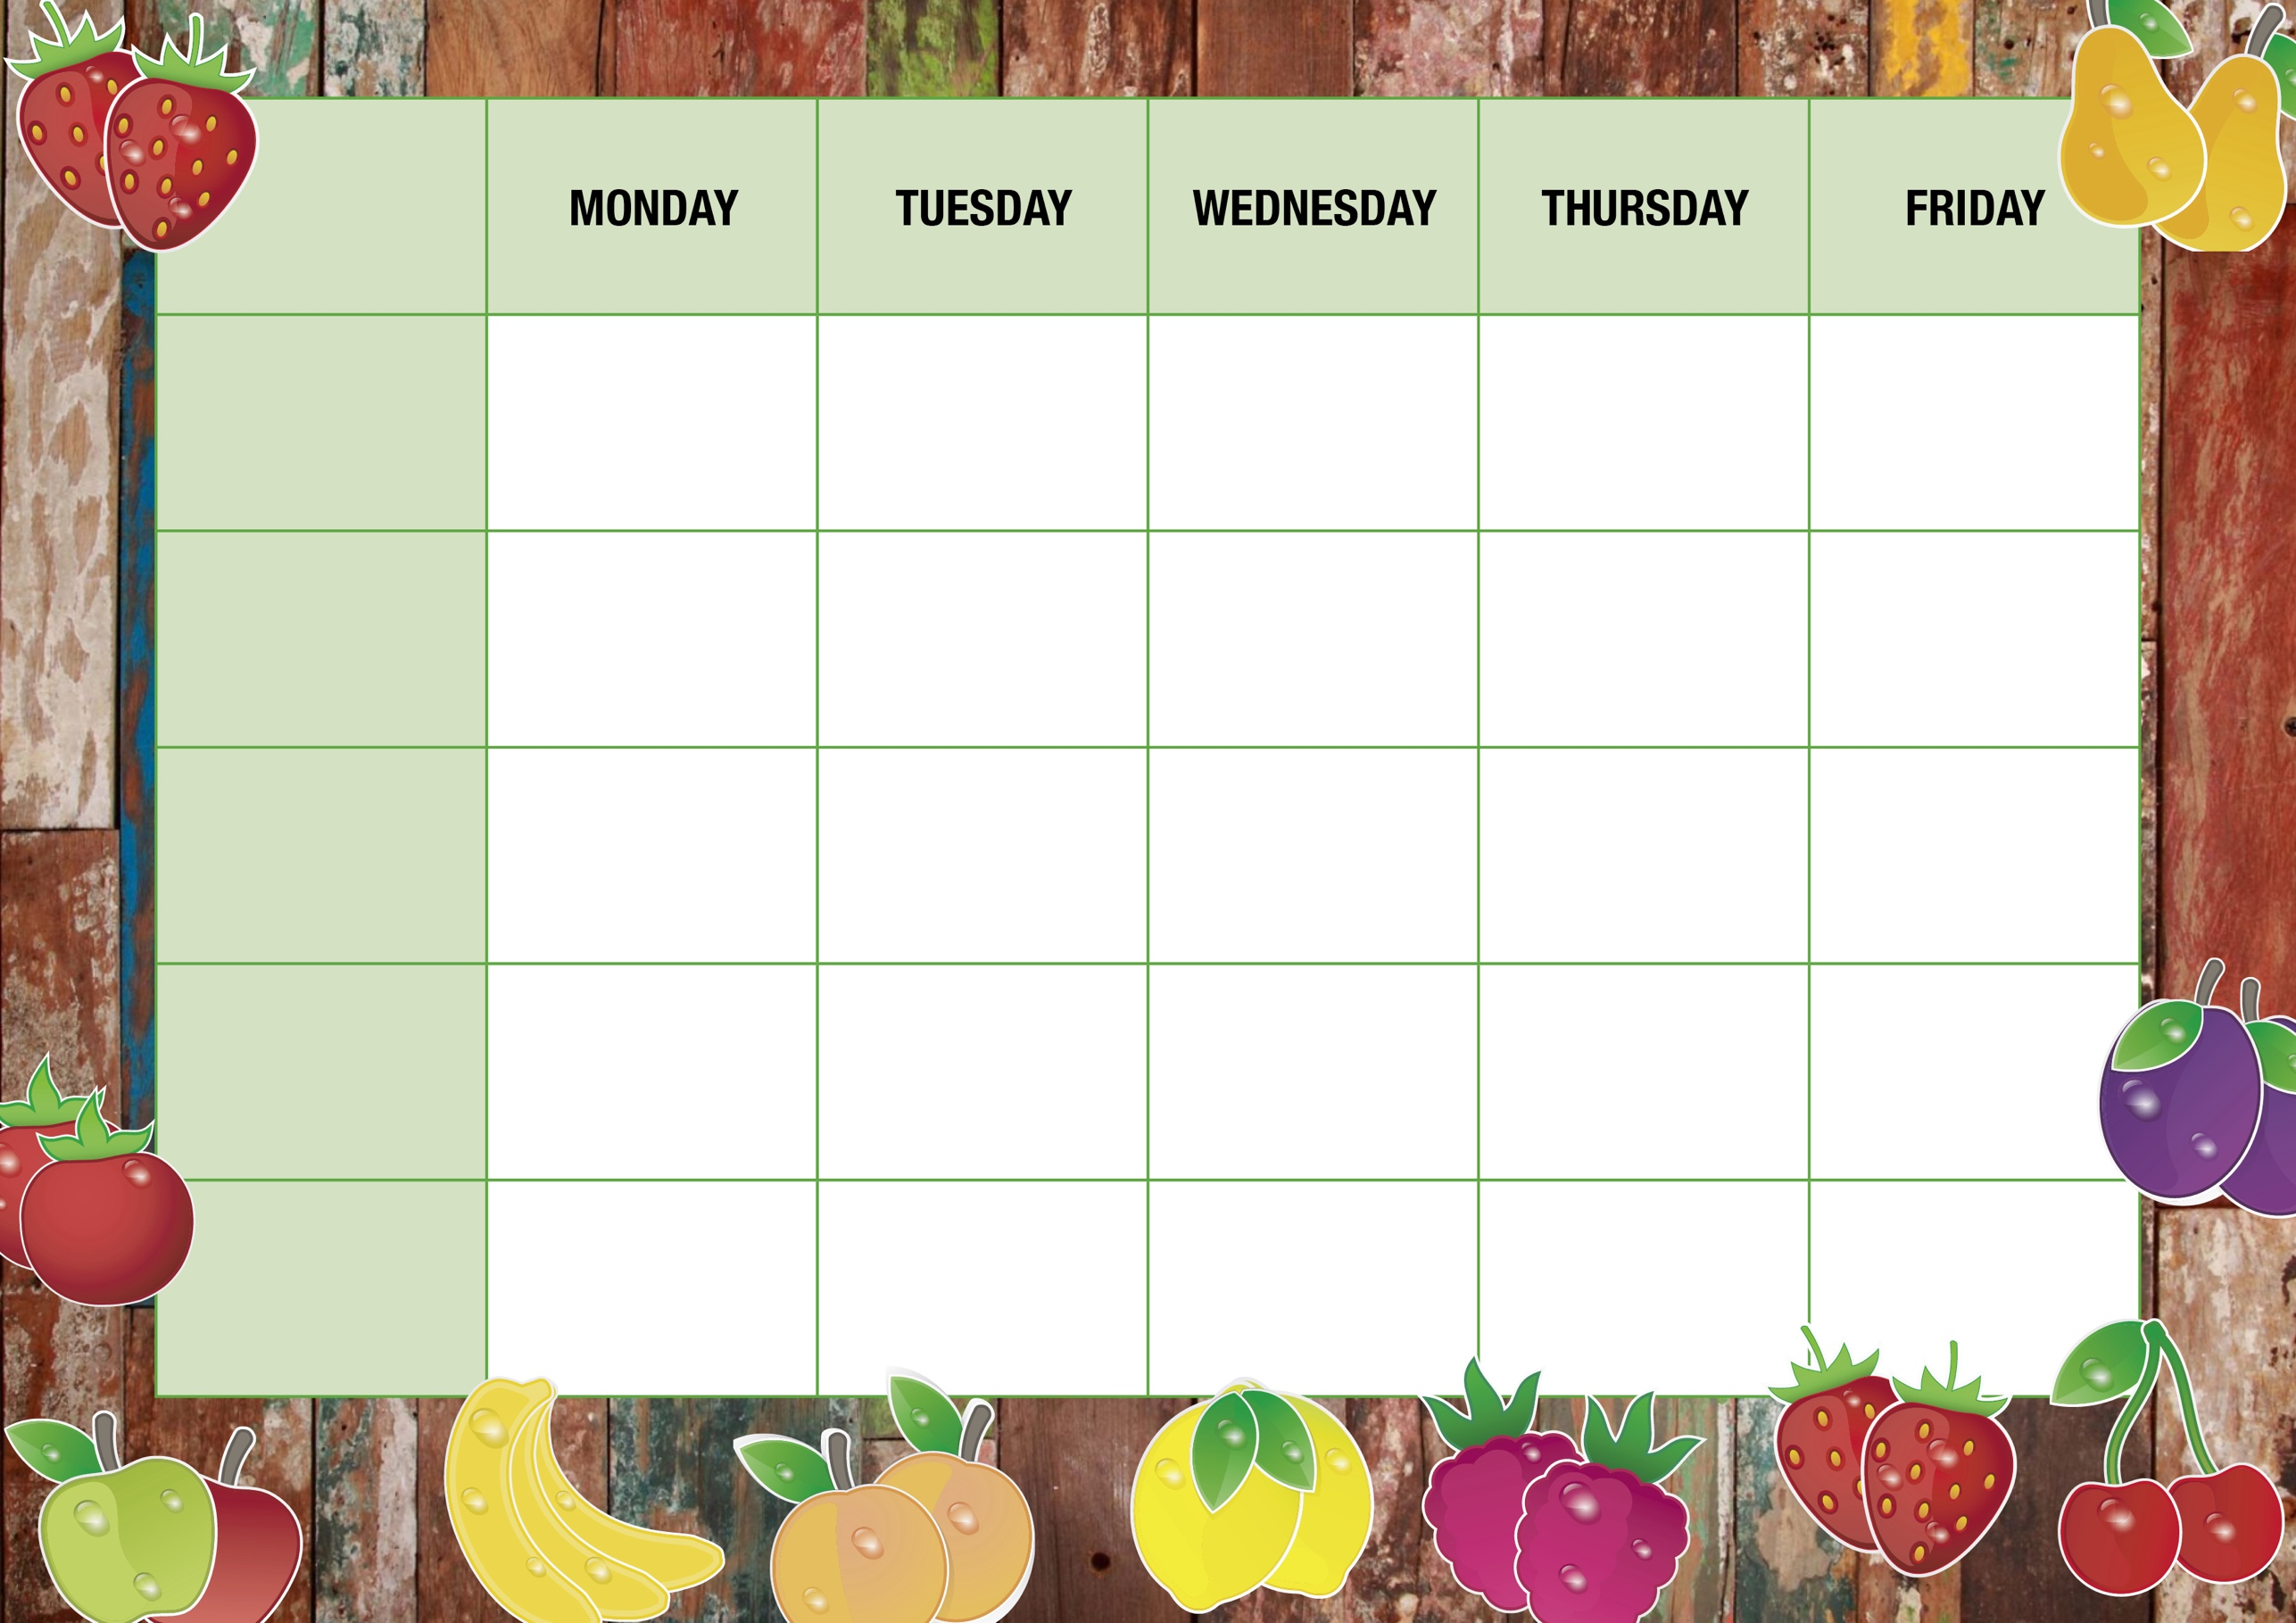

Iced Banana Cake Watermelon Yoghurts Cheese and Crackers

Fresh Fruit Meringue

Fresh Fruit Pot, whole fruit pieces

Assorted Yoghurts

Cheese & Crackers

Vegetable Chilli Taco

Fresh Fruit Pot, whole fruit pieces

Assorted Yoghurts

Cheese & Crackers

Mashed potato peas & beans

Mixed salad, fruit wedge, bread selection

Broccoli Crusty Bread

Mixed salad fruit wedge bread selection

Seasonal mixed veg, Mashed potato

Mixed salad, fruit wedge, bread selection

Rice, Garlic Bread

Mixed salad, fruit wedge, bread selection

baked beans Chips

Mixed salad, fruit wedge, bread selection

**Spud Stop, Pasta & Sandwiches**

**Sides**

Homemade Pizza Selection

Homemade Beef Chilli

Beef Cobbler

Baked Pork Sausage with onion gravy

Jumbo Fish Finger with tomato sauce

Penne pasta with tomato & basil sauce with crusty bread

Vegetable meatballs with gravy

Quorn sausage with onion gravy

Vegetarian Sausage Roll

Jacket Potato with cheese, beans or tuna mayo with side salad

Penne pasta with tomato & mascarpone sauce with crusty bread

Jacket Potato with cheese, beans or tuna mix with side salad

Penne pasta with tomato & basil sauce with crusty bread

Fresh Fruit Pot, whole fruit pieces

Assorted Yoghurts

Cheese & Crackers

Fresh Fruit Pot, whole fruit pieces

Assorted Yoghurts

Cheese & Crackers

**Main Meal 1**

**Week 2**

**Main Meal 2**

**Desserts**