Bikeability Year 1
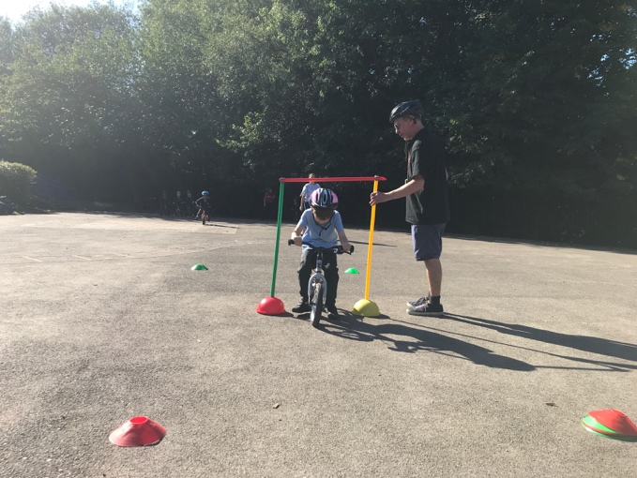
Year 1 take part in Bikeability Balance. They are taught the early cycle handling and awareness skills using games on balance bikes. The children enjoy becoming confident riders.
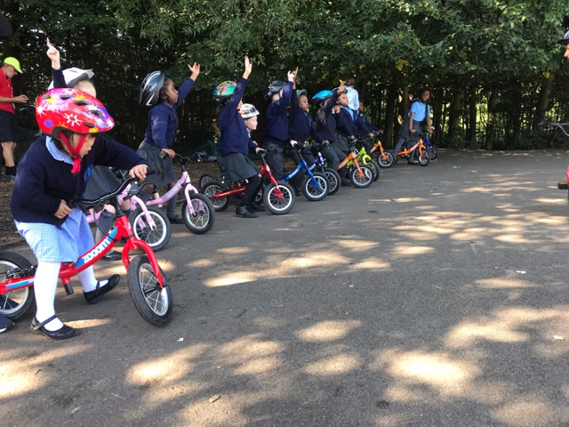
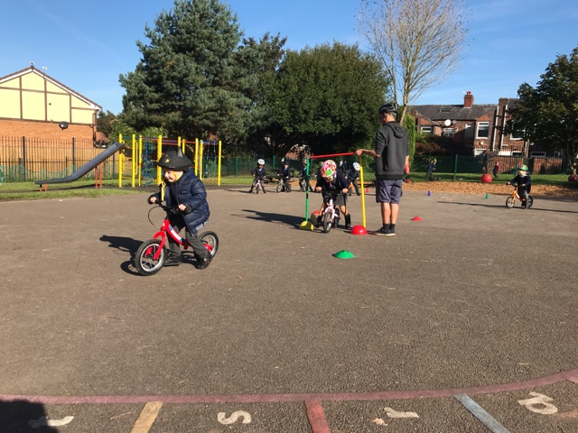
Bikeability Year 5
Year 5 children are taught how to ride bikes safely. Bikeability is delivered at 3 levels:

Level 1- is taught in a traffic-free environment, and children learn the basics of how to control their bike and make an off-road trip, for example on cycle paths.

Level 2- is covered on quiet roads but in real traffic conditions. Children achieving level 2 will be able to make a trip to school or elsewhere on small roads.

Level 3- incorporates busy roads, traffic lights, roundabouts and other advanced road features. Children will not usually be taught this until they start secondary school.

