Qualifying for the Healthy Start Scheme
The Healthy Start Card is for people who have very young children, and who have limited income.
You’ll get £4.25 each week of your pregnancy (from the 10th week of pregnancy), £8.50 each week for children from birth to 1 year old, and then £4.25 each week for children between 1 and 4 years old.
You can spend this money on items like milk, infant formula, tinned pulses, and fruit and vegetables.

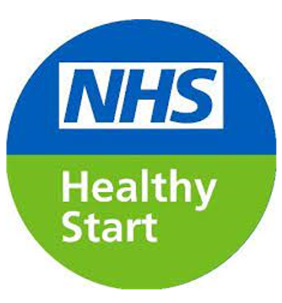

In addition, you must be receiving any of the following:
- Child Tax Credit (only if your family’s annual income is £16,190 or less)
- Income Support
- Income-based Jobseeker’s Allowance
- Pension Credit (which includes the child addition)
- Universal Credit (only if your family’s take-home pay is £408 or less per month from employment)

You will also be eligible for Healthy Start if:
- You’re under 18 and pregnant, even if you are not claiming any benefits
- You claim income-related Employment and Support Allowance (ESA) and are over 10 weeks pregnant
- You, your partner or your carer get Working Tax Credit run-on only after you have reported you’re working 16 hours or less per week

To find out if your family earns £408 or less per month from employment whilst claiming Universal Credit, look at your ‘take-home pay for this period’ on your monthly Universal Credit award notice.
Vitamins
You can also get free Healthy Start vitamins when you join the scheme. All you will need to do is show your card when you collect your vitamins from your nearest provider. Find you nearest provider here: www.healthystart.nhs.uk/getting vitamins.

How to apply
How to check if you are eligible, and how to apply
To check if you are eligible, or to apply directly, you will need your:
- name and address
- date of birth
- National Insurance number
- baby’s due date (if you’re pregnant)
- benefit award letter if you’re over 18 (you must enter the same information that’s on this letter)

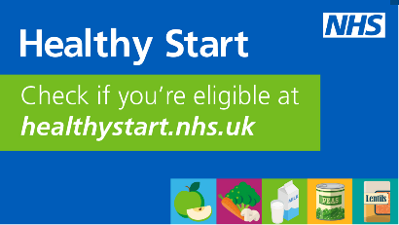

Apply on line at www.healthystart.nhs.uk. You can check eligibility immediately.
You will then receive your prepaid card in the post.
You must activate your card and get your PIN by calling 0300 330 2090 – Option 1
Funds will be added to the card automatically each month.
Points to note when applying
If you’re in the paper voucher scheme….
If you’re currently receiving paper vouchers for Healthy Start, these will stop once you complete the online application. You can still use your Healthy Start vouchers until their expiry date. You can find the expiry date printed on your vouchers.
You will need your benefits code to apply….
This can be found on your benefits award letter or should be on your universal credit online account. If you do not have it, your job centre should be able to reprint your letter
The system is telling me I am not eligible…..
Check that the name, address and other details you have used is exactly the same as the DWP/HMRC have on record for you including middle names. If this does not match, the system will reject your application.
This matches and I am still told I am not eligible…
The income limit of £16,190 applies to your whole family – so if your partner and you together earn more than this, you may not qualify for the scheme.

This matches and I am still told I am not eligible…
Some older benefits (legacy benefits) do not qualify you for Healthy Start even if your income is low. If you think this might apply to you, you will need to get individual advice on your position as it may not be good for you to move to a qualifying benefit. Citizens Advice can provide support in this area.
I don’t want to get a card, I want to keep using the vouchers! …
The NHS will no longer send the vouchers after the end of March, so if you want to keep receiving this benefit you will need to re-apply online.
I’ve applied and been told my application is “pending”, what does this mean….
It means that someone has to check to confirm you are eligible for the Healthy Start Scheme and someone from the Healthy Start Scheme will contact you shortly. You just need to wait for this to happen.
Generally, approval takes up to 7 working days. You can keep using any in-date vouchers you have, or get, from the scheme, until the card arrives.
Is it expensive to activate…
To activate your card telephone 0300 330 2090, then choose option 1. The call should only take a few minutes.
The number to call is free from a landline, and is included in the minutes of a monthly contract.
Does my card have my name on it?
The prepaid card is issued in the beneficiary’s name and can only be used by that person. Only one card can be issued to a claiming household.

Points to Note when Using the Card
Where can I use the card?
The card is like any prepaid Mastercard. You can use it anywhere that shows the Mastercard logo and a card payment facility allowing chip and pin, or contactless payments.
The shop has to sell the correct healthy start items - fruit and veg, milk, pulses. If your card is rejected, it may be that the store does not qualify.
How do I know how much is on the card?
You can check the balance on your card at an ATM or by calling 0300 330 7010
Can I use the card online?
No. The cards can only be used in store.
What if I have a problem with using the card?
If you have a problem and want to talk to an advisor or an intepreter call 0300 330 7010.
It’s worth knowing that these numbers are included free of charge in some pay plans and for landlines, but not all. If it’s not included in yours or you’re not on a pay plan you could be charged between 3 – 55p a minute from a mobile.
What if I lose my card?
If you lose your card or it is stolen, you must call the helpline immediately so the card can be stopped. Failure to do so may result in any funds on the card being lost.
You can request a new prepaid card by contacting the helpline. You should be sent a new card in the post within 7 working days.

What if my Immigration Status means I cannot claim benefits?
This a very complex area and you may need additional advice.
If you cannot claim one of the above benefits because of your immigration status, you may still qualify for the Healthy Start Scheme. You must fulfil all of the following criteria:
- Be responsible for at least one British child under 4 years old, and
- You have no Recourse To Public Funds (Benefits), and
- Your family earns less than £408 per month after tax
Your biometric residence permit (BRP) or your online immigration status will tell you if you cannot claim public funds. You might also have a letter from the Home Office about it.
To get Healthy Start vouchers, ask for an application form via email. Only use this email address if you think you cannot claim public funds because of your immigration status.
Healthystartclaim@dhsc.gov.uk

