

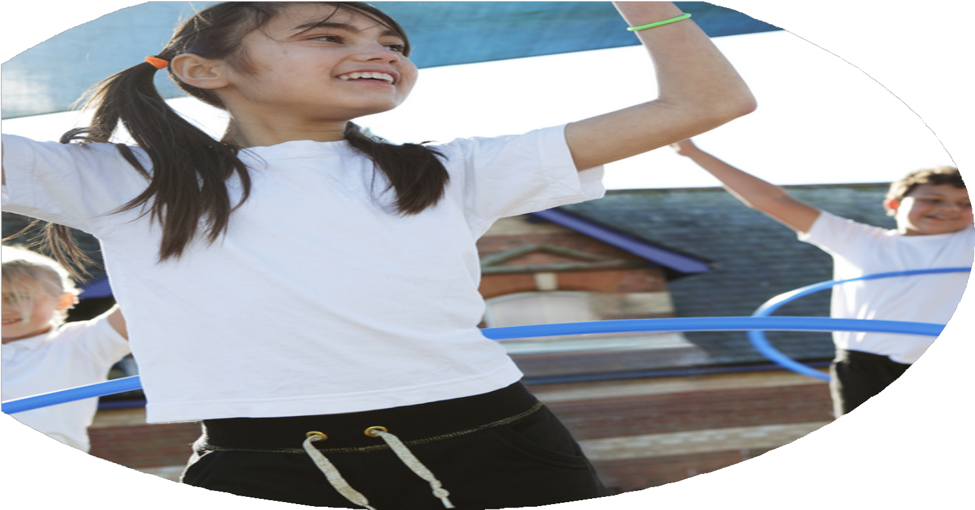
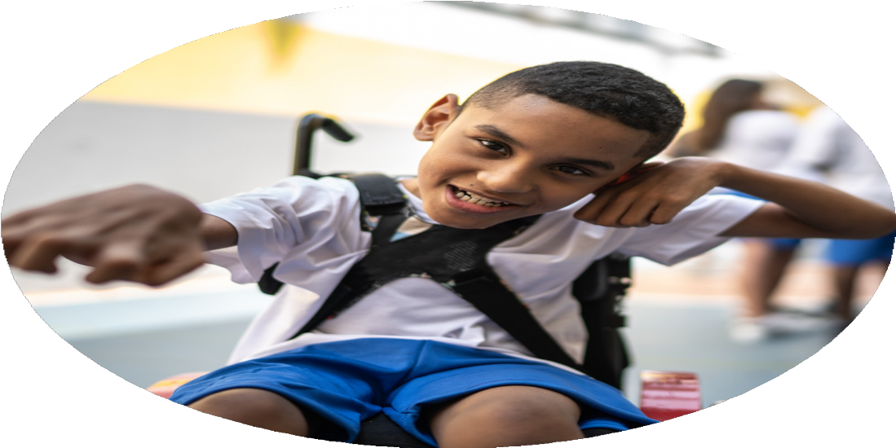
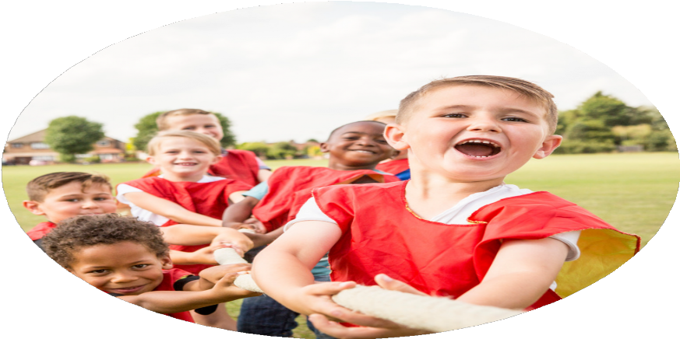



PE Funding

Evaluation Form

Commissioned by

Created by

Images courtesy of Youth Sport Trust

PE Funding Evaluation Form

It is intended that this template should be used as preparation for the completion of the statutory digital reporting tool being introduced this academic year. You can upload data (including swimming) from this template onto this platform once it becomes accessible.
Before you decide how you are going to use the funding for this academic year you should reflect and evaluate the impact of your use of the funding in 2023/24.
All spending of the funding must conform with the terms outlined in the Conditions of Grant document. The template is a working document that you can amend/update during the year.
Based on your evaluation of last year’s funding you should decide what you intend to do this academic year, how you will do it, and what impact you expect it to have.

It is important that the funding is used effectively and based on your school’s needs.
You must use the funding to make additional and sustainable improvements to the PE and sport in your school. You must develop and add to the PESSPA activities that your school already offers.

Summative digital reporting from June 2025 will continue to include swimming and water safety information therefore funding can be used to provide top-up lessons where necessary to ensure pupils meet national curriculum swimming requirements.

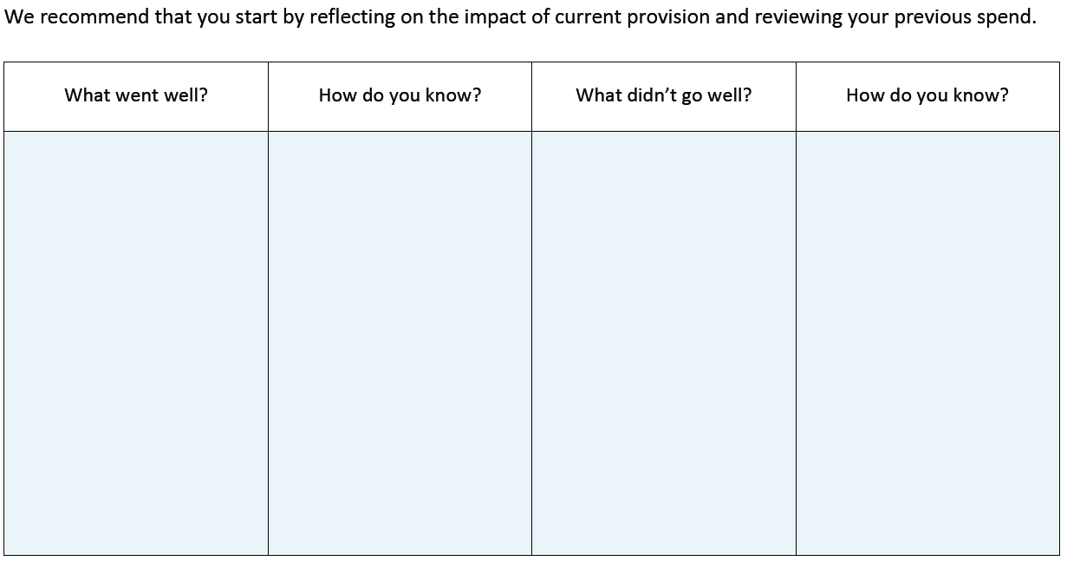
More children could have had the opportunity to represent the school in school sport competitions.
Children had the opportunity to take part in school football competitions and some other sports competitions, but more children could take part in school competitions.
More children are taking part in physical activity throughout the day and meeting their 60 active minutes. There is increased participation of children in activities throughout the day and after school. There is an increased number of children with SEN taking part in physical activity.

Through accessing of wellbeing workshops children understand the benefit of being physically active and other techniques to promote their wellbeing. Children are able to utilise the skills they learn in these sessions throughout the school day.

Effective teaching of PE was observed last year across the school. Teachers fed back positively about the scheme and their own development by teaching PE twice a week.
Introduction of new sports and activities at lunch times and after school.

Whole school Wellbeing sessions.

Teachers delivering two PE lessons per week using the Get set 4 PE scheme.
What are your plans for 2024/25?

Intent
How are you going to action and achieve these plans?

Implementation
- Timetabled after-school and lunchtime clubs provided by Fifth Movement, including a variety of activities to cater to different interests and abilities. Promotion of clubs through school newsletters and assemblies to encourage participation. Monitoring of attendance and participation to ensure targeted children are accessing opportunities.
- Weekly wellbeing sessions delivered to every year group by Fifth Movement. Regular feedback from pupils and staff to assess the impact of wellbeing sessions.
- Whole-school subscription to Get Set 4 PE scheme. Staff training sessions to support the effective use of the scheme. Lesson observations and peer support to ensure consistency in delivery. Use of assessment tools within the scheme to track pupil progress.
- Attendance at Team MCR CPD sessions. Staff training sessions to share key learning and updates. Evaluation of staff confidence and areas for development.
- Participation in local sports partnerships and School Games events. Organisation of intra-school competitions within year groups. Development of sports teams to represent the school in external competitions.
- Regular audit of PE equipment to identify gaps and areas for improvement. Purchase of new equipment to support curriculum delivery and extracurricular clubs. Safe storage and organisation of equipment to ensure easy access.

- To continue to work with Fifth movement to deliver a range of after school and lunchtime activities to ensure children reach 60 active minutes in school.

- To continue to work with Fifth movement to deliver wellbeing sessions to develop children’s resilience and have strategies they can use throughout the school day.

- The continuation of the Get set 4 PE scheme to meet the expectations of the PE curriculum and continue to develop teachers’ skills in planning, delivering and assessing children’s skills in PE.

- The PE subject lead to attend CPD sessions to stay up to date with current research and strategies to develop effective strategies and implementation of PESSPA. PE subject lead to feedback to staff best practice.

- To give the children opportunities to participate in intra/inter school competitions to give children the opportunity to take part and use the skills they have developed in PE in competition.

- To maintain school equipment and ensure the curriculum is fully resourced.

What impact/intended impact/sustainability are you
expecting?
How will you know? What evidence do you have or
expect to have?
- Attendance registers and participation data from after-school and lunchtime clubs will show increased numbers of children engaging in physical activity.
- Pupil voice surveys and wellbeing questionnaires will reflect improved confidence and resilience, alongside anecdotal feedback from staff and parents.
- Lesson observations, planning scrutiny, and assessment data will demonstrate consistent, high-quality delivery of the PE curriculum and pupil progress.
- Staff feedback forms and evaluation of CPD sessions will indicate increased confidence and knowledge in delivering PE lessons.
- Registers of competition participants, School Games Mark accreditation, and pupil voice feedback will highlight increased opportunities for children to participate in competitive sports.
- Equipment inventories and regular audits will show that resources are well-maintained and fully support the curriculum delivery, alongside staff feedback on resource quality and accessibility.

- Increased participation in physical activity, supporting children's physical health and encouraging long-term habits of leading active lifestyles.
- Improved emotional wellbeing and resilience, enabling children to apply coping strategies in both school and home life, supporting long-term mental health.
- Consistent delivery of high-quality PE lessons, enhancing children's skills and knowledge while developing staff confidence in delivering the curriculum.
- Improved staff confidence and expertise in delivering PE lessons, ensuring a lasting impact on the quality of PE provision across the school.
- Increased confidence, teamwork, and motivation among pupils, with more children experiencing competitive sport and understanding the value of participation.
- Improved access to high-quality equipment, supporting consistent delivery of the PE curriculum and enhancing children's physical development and enjoyment of physical activity.

What impact/sustainability have you seen?
What evidence do you have?
To be reviewed in Summer 2.
To be reviewed in Summer 2.

