7th September, 2018

Dear Parents/Carers,

Online Free School Meal Eligibility Checker
The way that Free School Meals are processed has changed. Instead of filling in a claim form which was processed by the Revenue and Benefits department, Manchester City Council have changed this and the process is now done online.

We urge all parents to apply even if you know/think you are not eligible. This is because once you have applied, your details will stay live on the checker. The checker updates itself every day so if there are any changes to your circumstances this will automatically pick you up and you will be entitled straight away, even if this is just for a couple of days, you are covered immediately and we are notified.

If you are currently entitled, we ask you to complete this form to ensure your eligibility continues as Revenue and Benefits no longer notify us of your eligibility.

As well as yourselves, school benefits from this because we get funding for your child if they are entitled. In the current climate, with budgets so tight, every penny helps.

To apply, go to www.manchester.gov.uk and click on ‘Benefits and Support’…
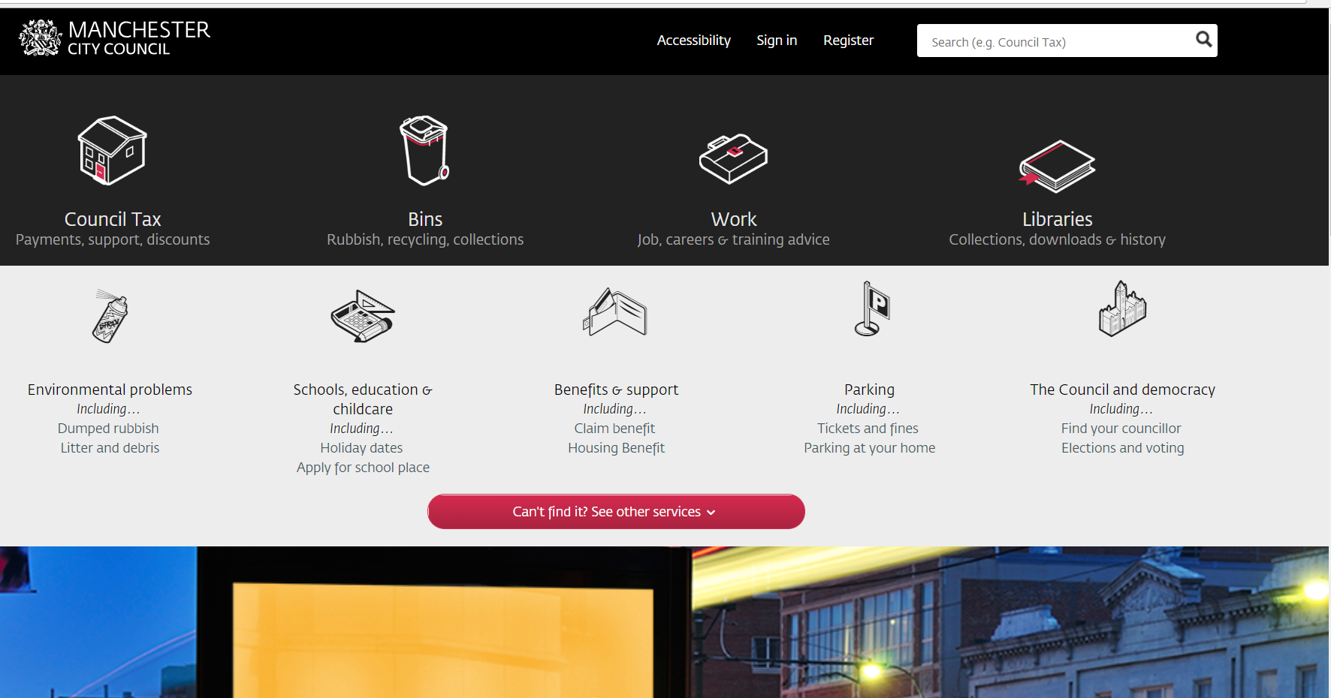
Then click on ‘Free School Meals’…
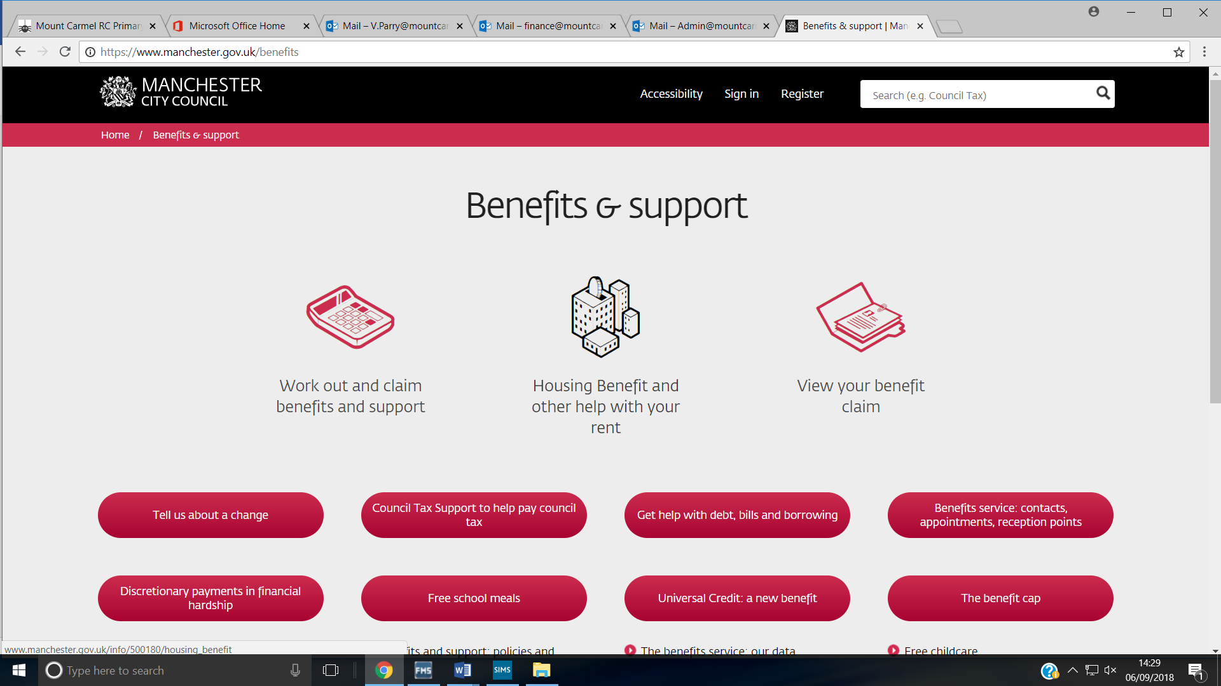

Then click on ‘Apply Using the Free School Meals Portal’…
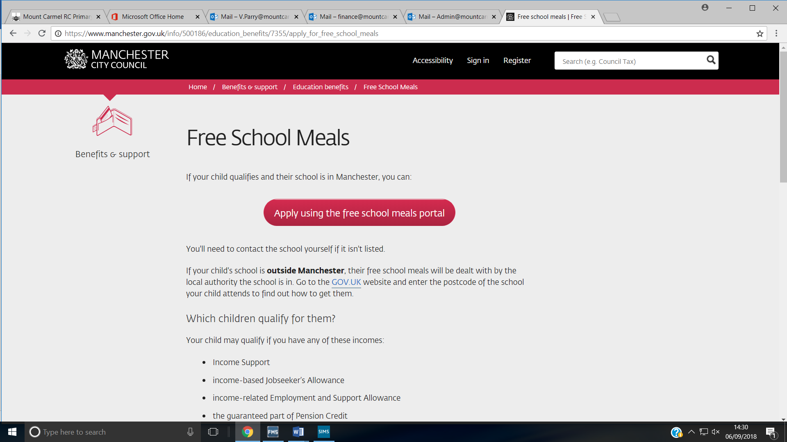

This is the portal you will see…

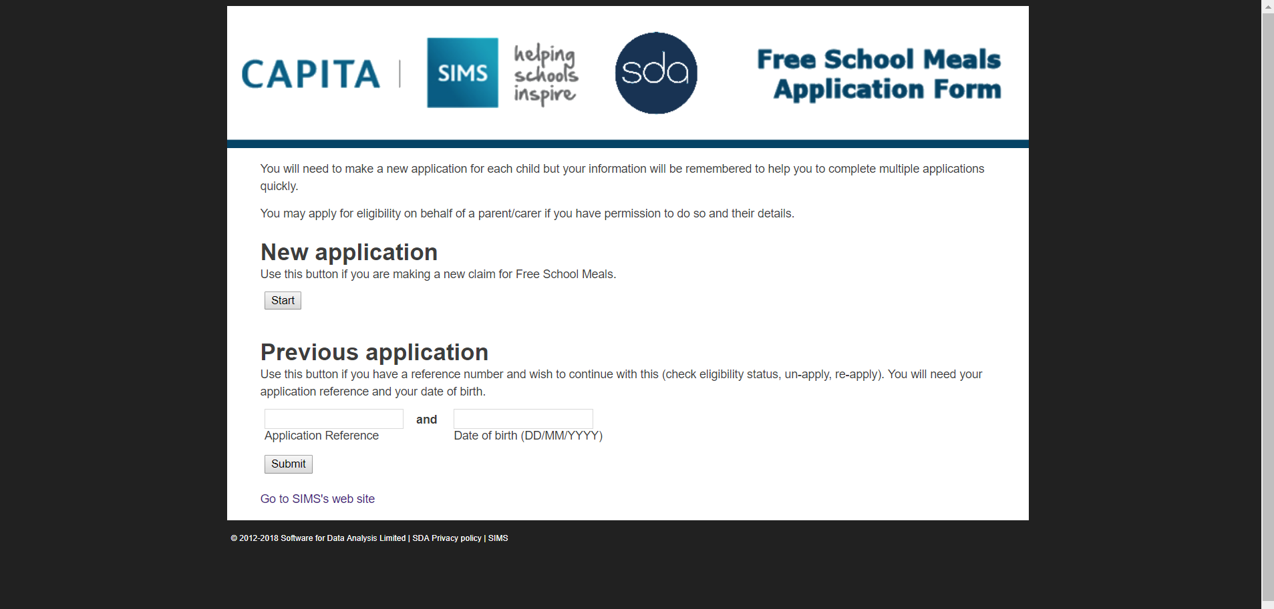

Please complete the portal and you will be informed if you are eligible or not. We will also receive confirmation of this.

This is a great way to ensure eligibility is never missed and will benefit yourselves and the school.

Yours sincerely,

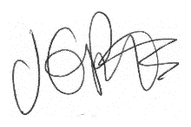

Jacqui Potts
Headteacher

