Friday 2nd February, 2024

Dear Parents/Carers,

ADVANCE NOTICE OF NURSERY BEING CLOSED FOR VOTING DAY – THURSDAY 2ND MAY, 2024

Please note, we wanted to give you advance notice that the Nursery will be CLOSED to all children, on Thursday 2ND May as it is going to be used as a Polling Station for voting for the Local Elections and for Greater Manchester Mayoral Election. Apologies for any inconvenience this may cause.

Yours sincerely

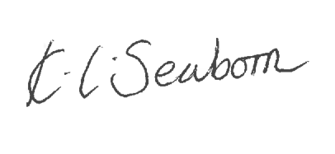
K. Seaborn
Head Teacher

