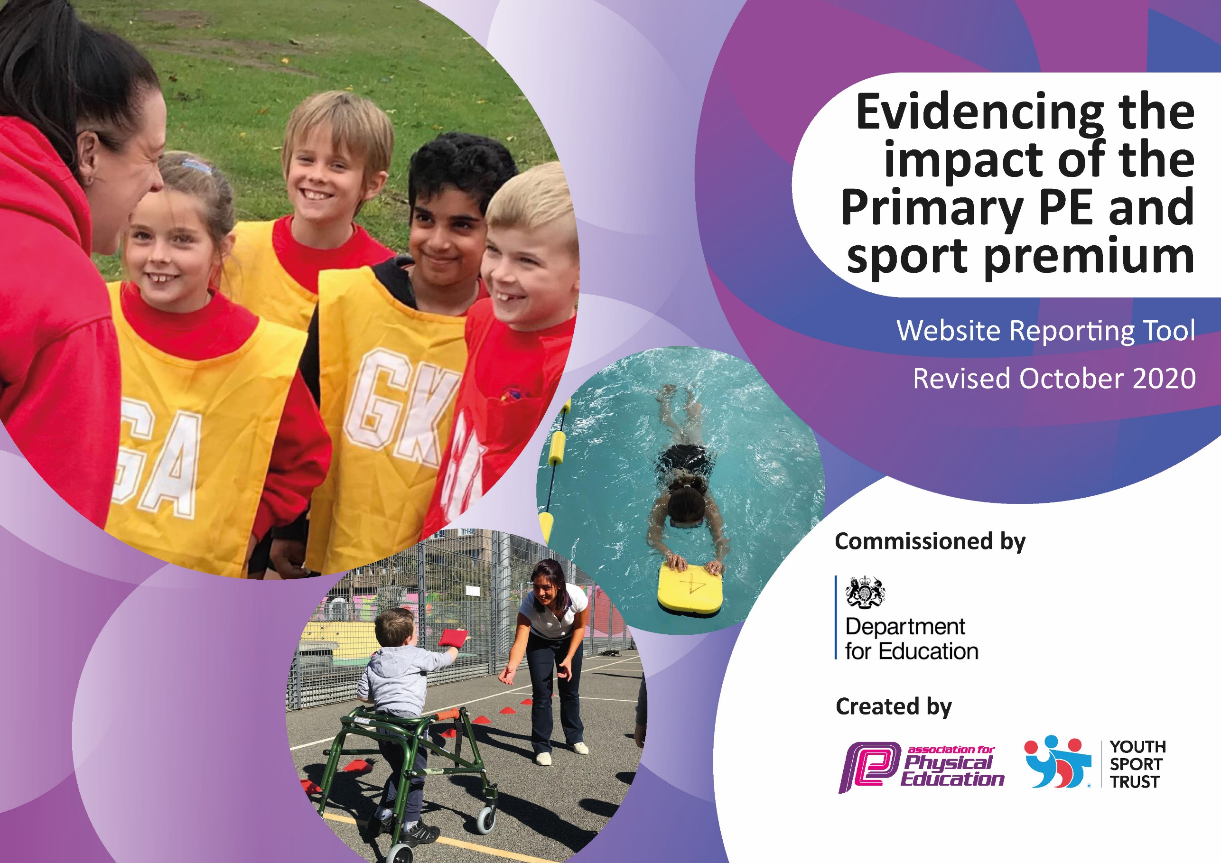
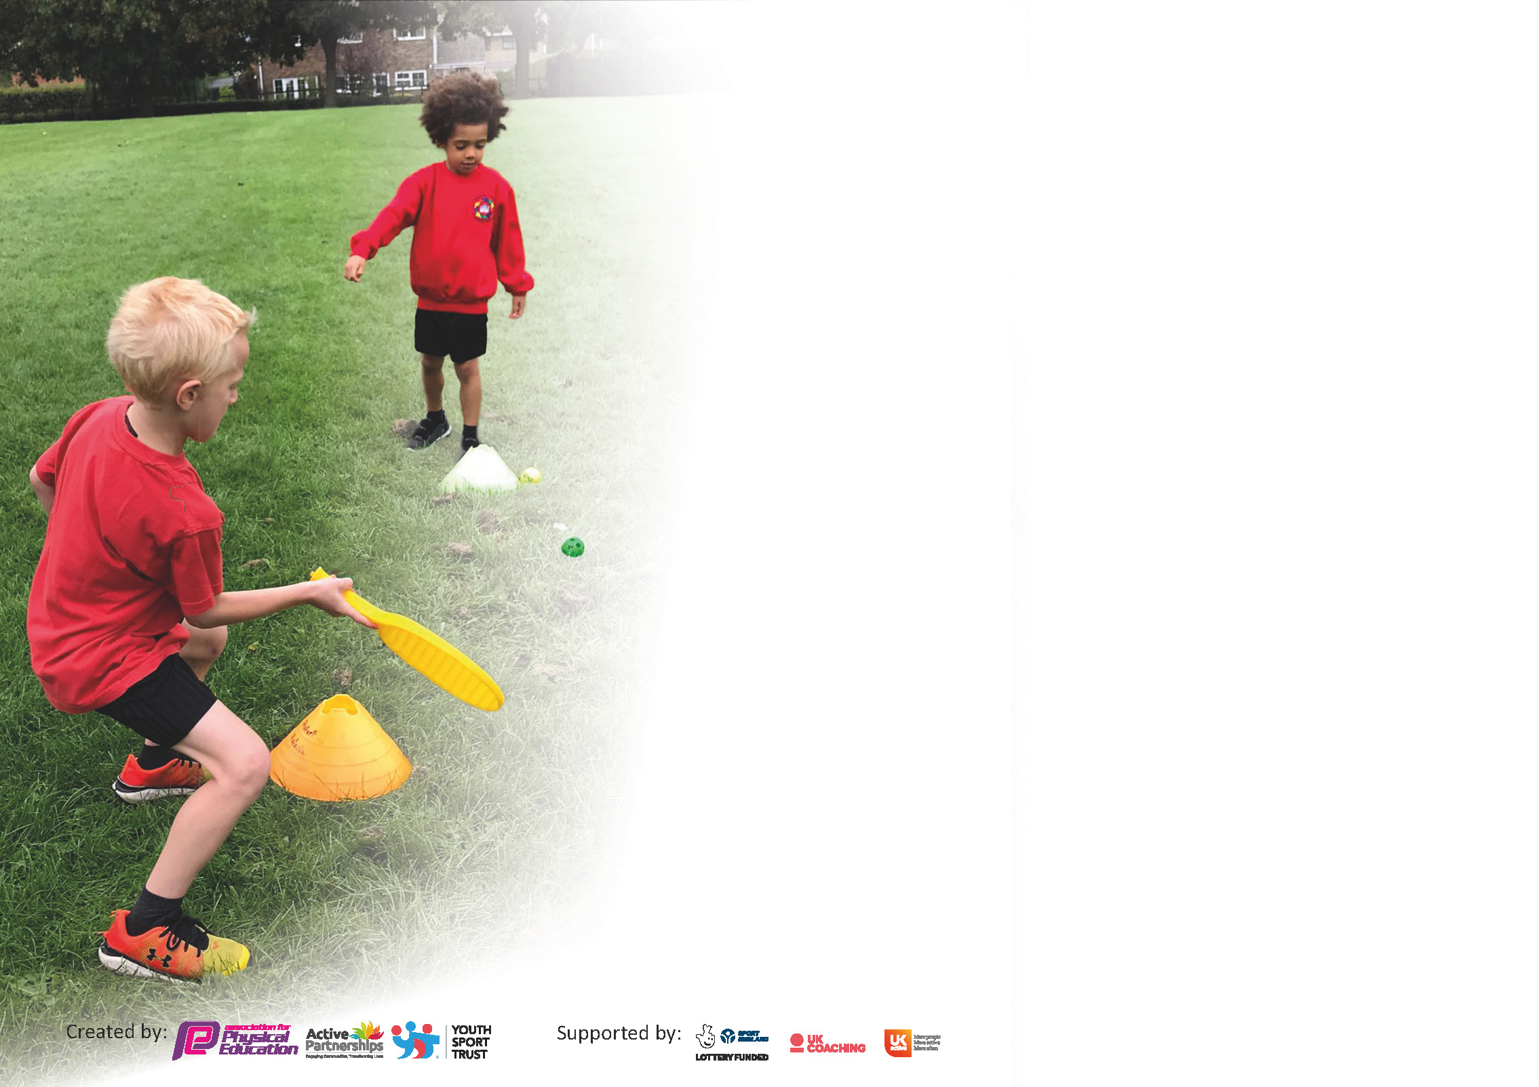

It is important that your grant is used effectively and based on school need. The Education Inspection Framework (Ofsted 2019 p64) makes clear there will be a focus on ‘whether leaders and those responsible for governors all understand their respective roles and perform these in a way that enhances the effectiveness of the school’.

Under the Quality of Education criteria (p41) inspectors consider the extent to which schools can articulate their curriculum (INTENT), construct their curriculum (IMPLEMENTATION) and demonstrate the outcomes which result (IMPACT).

To assist schools with common transferable language this template has been developed to utilise the same three headings which should make your plans easily transferable between working documents.

Schools must use the funding to make additional and sustainable improvements to the quality of Physical Education, School Sport and Physical Activity (PESSPA) they offer. This means that you should use
the Primary PE and sport premium to:

- Develop or add to the PESSPA activities that your school already offer
- Build capacity and capability within the school to ensure that improvements made now will benefit pupils joining the school in future years

Please visit gov.uk for the revised DfE guidance including the 5 key indicators across which schools should demonstrate an improvement. This document will help you to review your
provision and to report your spend. DfE encourages schools to use this template as an effective way of meeting the reporting requirements of the Primary PE and sport premium.

We recommend you start by reflecting on the impact of current provision and reviewing the previous spend.

Schools are required to publish details of how they spend this funding as well as on the impact it has on pupils’ PE and sport participation and attainment by the end of the summer term or by 31st July 2021 at the latest.

** In the case of any under-spend from 2019/20 which has been carried over this must be used and published by 31st March 2021.

We recommend regularly updating the table and publishing it on your website throughout the year. This evidences your ongoing self-evaluation of how you are using the funding to secure maximum, sustainable impact. Final copy must
be posted on your website by the end of the academic year and no later than the 31st July 2021. To see an example of how to complete the table please click HERE.
Created by: Supported by:

Please note: Although there has been considerable disruption in 2020 it is important that you publish details on your website of how you spend the funding - this is a legal requirement.
Support for review and reflection - considering the 5 key indicators from DfE, what development needs are a priority for your setting and your pupils now and why? Use the space below to reflect on previous spend and key achievements and areas for development.

N.B. In this section you should refer to any adjustments you might have made due to Covid-19 and how these will influence further improvement.
Key achievements to date until July 2020: | Areas for further improvement and baseline evidence of need:
- European School Sports Day- September.  - Intra-sport (Dance- whole school).  - National School Sport Week  - Re-engaged children in physical activity. All classes have the resources to engage in physical activity with their class.  - Profile of PE, sport and physical activity raised (twitter and website)  - Pupil voice (over 90% of children report they enjoy P.E).  - Positive community link with MCFC. Increased awareness of opportunities in the community.  - Improved staff knowledge and understanding.  - Infant department has more opportunities for children during lunchtimes. | - Re-establish after school clubs (cancelled programmes).  - Re-establish sporting life of the school to compete in inter- competitions (cancelled programmes).  - Provide training in delivering FMS through gymnastics and orienteering. (Teacher feedback.)  - Support EYFS with the delivery of the new EYFS framework.

Did you carry forward an underspend from 2019-20 academic year into the current academic year? YES

If any funding from the academic year 2019/20 has been carried over you MUST complete the following section. Any carried over funding MUST be spent by 31 March 2021.
Academic Year: September 2020 to March 2021 | Total fund carried over: £3,894.86 | Date Updated: March 2021
What Key indicator(s) are you going to focus on? |  |  |  | Total Carry Over Funding:
 |  |  |  | £3894.86(Spent- £3895.41)
Intent | Implementation |  | Impact
Your school focus should be clear how you want to impact on your pupils.  Raise awareness of the physical and mental health benefits of walking and help to create healthy habits for life.  Provide children with the opportunity to apply the skills learnt in core swimming lessons to achieve more than 25m. (Covid-19 adjustment. Redirected funding that was allocated for resources and training in order to support children with top-up swimming lessons to have more pool experience. Y4 cohort: 25m- 87%/ 50m- 23%)  To assist teachers and re-engage children in achieving 30 minutes of daily physical activity.  Children in Reception have a positive experience of being physically active and attain the gross motor skills needed to have a good start for formal PE lessons. | Make sure your actions to achieve are linked to your intentions:  Purchase walk to school packs for classes in order to engage children and their families.  Purchase top- up swimming lessons for children who require more experience in the water and have the opportunity to gain 50m award. (Previous cohort 66% achieved 50m).  To purchase equipment (e.g. skipping ropes, balls etc.) for every class so they can be used during wellbeing breaks and playtime equipment.  City Play delivered to Reception to prepare the children for PE | Carry over funding allocated:  £160  £1700  £1345.41  £690 | Evidence of impact: How can you measure the impact on your pupils; you may have focussed on the difference that PE, SS & PA have made to pupils re-engagement with school. What has changed?:  Families choose to walk to school and children see the physical and mental benefits of walking.  Children are confident swimmers and achieved awards above 25m. Children have the knowledge and skills to be safe around water and want to continue swimming. (25m- 92%/ 50m- 76%)  Children are engaging in at least 30 minutes of physical activity a day in school. All classes have the resources to re-engage children with physical activity.  Children are ready for PE lessons in Year 1. | Sustainability and suggested next steps and how does this link with the key indicators on which you are focussing this academic year?:  More families choose to walk to school and children develop healthy habits for life.  Continue to have 90% and above of children achieving 25m and aim for children to achieve 50m. Children leave primary school having the knowledge and skills to be safe around water and continue to swim.  Every class has the resources to engage in physical activity.  EYFS provides a strong foundation for developing the fundamental movement skills in KS1 & 2.

Meeting national curriculum requirements for swimming and water safety.

N.B Complete this section to your best ability. For example you might have practised safe self-rescue techniques on dry land.
What percentage of your current Year 6 cohort swim competently, confidently and proficiently over a distance of at least 25 metres?  N.B. Even though your pupils may swim in another year please report on their attainment on leaving primary school at the end of the summer term 2020. | 79%
What percentage of your current Year 6 cohort use a range of strokes effectively [for example, front crawl, backstroke and breaststroke]? | 52%
What percentage of your current Year 6 cohort perform safe self-rescue in different water-based situations? | 65%
Schools can choose to use the Primary PE and sport premium to provide additional provision for swimming but this must be for activity over and above the national curriculum requirements. Have you used it in this way? | Yes

Action Plan and Budget Tracking
Capture your intended annual spend against the 5 key indicators. Clarify the success criteria and evidence of impact that you intend to measure to evaluate for pupils today and for the future.

Academic Year: 2020/21 | Total fund allocated: £19,560 | Date Updated: 09.07.21
Key indicator 1: The engagement of all pupils in regular physical activity – Chief Medical Officers guidelines recommend that primary school pupils undertake at least 30 minutes of physical activity a day in school |  |  |  | Percentage of total allocation:
 |  |  |  | 21%
Intent | Implementation |  | Impact
Your school focus should be clear what you want the pupils to know and be able to do and about  what they need to learn and to  consolidate through practice: | Make sure your actions to achieve are linked to your intentions: | Funding allocated: | Evidence of impact: what do pupils now know and what can they now do? What has changed?: | Sustainability and suggested next steps:
To assist teachers in ensuring children achieve 30 minutes of physical activity every day.  To assist teaching assistants in ensuring children achieve 30 minutes of physical activity every day. | City in the Community to target less active pupils at lunchtime. (Extend this to the Infant department)  Equipment for active playtimes. | £3996.67  £210.62 | Website and twitter show we are promoting living a healthy lifestyle.  Children have a positive attitude towards leading healthy lifestyles.  Children are engaged in at least 30 minutes of physical activity a day in school. | Pupils know how to play games that are active during playtimes.  Children have the resources to engage in physical activity during playtimes.
Key indicator 2: The profile of PESSPA being raised across the school as a tool for whole school improvement |  |  |  | Percentage of total allocation:
 |  |  |  | 12%
Intent | Implementation |  | Impact
Your school focus should be clear what you want the pupils to know and be able to do and about  what they need to learn and to  consolidate through practice: | Make sure your actions to achieve are linked to your intentions: | Funding allocated: | Evidence of impact: what do pupils now know and what can they now do? What has changed?: | Sustainability and suggested next steps:
Children are provided with various opportunities to learn about being healthy and staying active as part of the curriculum and through extra-curricular activities.  Children have the skills to be able to ride a bike and participate in the Bikeability programme in school. | PE Co-ordinator to attend subject leader meetings. (Discounted- 3-year advanced payment.)  EYFS- purchase 5x balance bikes/ helmets/ resource pack and 1x orientation session.  Y1 Bikeability balance with instructors (part grant funded) | £595 (£109.73 supply cover)  £981.60  £600 | Applying good practice in the school.  Children in EYFS and Y1 gained the confidence and skills required to ride a pedal bike independently. | Sharing good practice between schools to ensure we are always delivering the best for our pupils.  Children have the best start to cycling and assisting their ability to participate in Bikeability.

Key indicator 3: Increased confidence, knowledge and skills of all staff in teaching PE and sport |  |  |  | Percentage of total allocation:
 |  |  |  | 43%
Intent | Implementation |  | Impact
Your school focus should be clear | Make sure your actions to | Funding | Evidence of impact: what do | Sustainability and suggested
what you want the pupils to know | achieve are linked to your | allocated: | pupils now know and what | next steps:
and be able to do and about | intentions: |  | can they now do? What has
what they need to learn and to |  |  | changed?:
consolidate through practice:
To maintain quality teaching of the PE curriculum by all staff so children receive high quality teaching and learning. | City coaches support teachers in the delivery of the curriculum.  NQT High Quality PE training for one member of staff (5 courses).  EYFS High Quality Courses (3 courses). | £7993.33  £250  £150 | Teachers are using the framework to deliver PE lessons. Observations and assessment demonstrate high quality teaching and learning. Teachers are confident in delivering FMS through a variety of activities.  Children in EYFS are ready for P.E. in Y1. Teachers have knowledge of the new 2021 EYFS curriculum. | Up-to-date training on delivering the curriculum. Teachers are confident in delivering PE.
Key indicator 4: Broader experience of a range of sports and activities offered to all pupils |  |  |  | Percentage of total allocation:
 |  |  |  | 14%
Intent | Implementation |  | Impact
Your school focus should be clear | Make sure your actions to | Funding | Evidence of impact: what do | Sustainability and suggested
what you want the pupils to know | achieve are linked to your | allocated: | pupils now know and what | next steps:
and be able to do and about | intentions: |  | can they now do? What has
what they need to learn and to |  |  | changed?:
consolidate through practice:
Additional achievements:  Increased participation in children leading a healthy and active lifestyle.  Provide children with the opportunity to apply the skills learnt in core swimming lessons to achieve more than 25m. (Covid-19 adjustment. Redirected funding that was allocated for resources and training in order to support children with top-up swimming lessons to have more pool experience. Y4 cohort: 25m- 87%/ 50m- 23% | MCR active membership fee  Showcase lessons of Rugby and dance for NSSW.  City in the Community provide additional activities to introduce new sports or activities to the children.  Active Storytelling training for one member of staff.  Purchase top- up swimming lessons for children who require more experience in the water and have the opportunity to gain 50m award. (Previous cohort 66% achieved 50m). | £1300  £350  (Part of the subscription fee for other services)  Free (£109.73  supply cover)  £1020 | Children will want to participate in after school clubs.  Children are enthusiastic about the role of sport in their lives and see the relevance of living a healthy lifestyle.  Children who are less active are able to participate in activities that they find more engaging.  Children are confident swimmers and achieved awards above 25m. Children have the knowledge and skills to be safe around water and want to continue swimming (25m- 92%/ 50m-76%.) | Children will continue to attend after school clubs as they see the benefit.  Children find the sport/ activity that they will continue.  Children’s increased confidence leads them to participate in extra- curricular sport.  Continue to have 90% and above of children achieving 25m and aim for children to achieve 50m. Children leave primary school having the knowledge and skills to be safe around water and continue to swim.

Key indicator 5: Increased participation in competitive sport |  |  |  | Percentage of total allocation:
 |  |  |  | 10%
Intent | Implementation |  | Impact
Your school focus should be clear | Make sure your actions to | Funding | Evidence of impact: what do | Sustainability and suggested
what you want the pupils to know | achieve are linked to your | allocated: | pupils now know and what | next steps:
and be able to do and about | intentions: |  | can they now do? What has
what they need to learn and to |  |  | changed?:
consolidate through practice:
Provide opportunities for children to take part in intra/ inter competitive sports | Annual Manchester PE Association Fee (2 years)  Transport to competitions  Trophies to award for School Games | £1750  £50  £93.32 | Children are taking part in intra and inter- sport. Children feel a sense of achievement. | Sporting networks are well-established.  All pupils have experience of competitive sports and are developing the School Games Values.

Signed off by
Head Teacher: | JE Potts
Date: | 22/07/2021
Subject Leader: | K. Dale
Date: | 09.07.21
Governor:
Date:

