26/04/2023

Dear Parents and Carers,
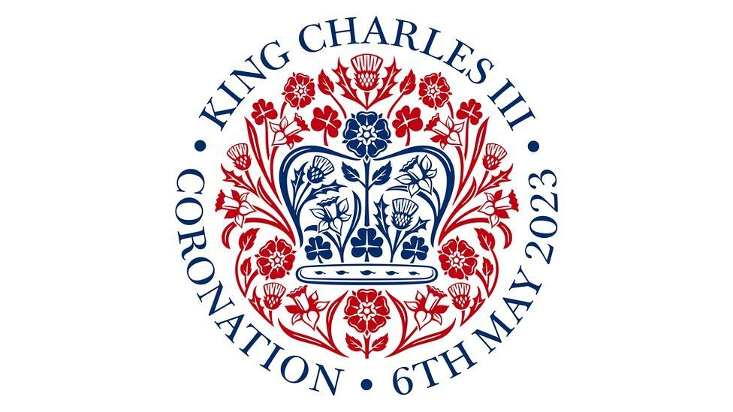
To celebrate King Charles III Coronation, we will celebrate in school on Thursday 4th May. All children are welcome to come to school dressed as a King, Queen, Prince, Princess, member of the royal household or in their party wear (sensible footwear please).

All children will take part in history activities in their year group to learn about the coronation ceremony and the importance for the royal family. Children will make crowns that they can wear for the day.

There is a special coronation school lunch (picnic- hopefully outside) that can be ordered. If you would like your child to take part in this lunch, please log into School Grid to order.

We hope to make this a memorable day for the children and will ensure we take many photographs on the day so please follow us on Twitter @Mount_Carmel1.

Our Nursery is closed on Thursday 4th May. Our Nursery children will be celebrating on Friday 5th May.

Kind regards,

Mrs Seaborn

Deputy Headteacher

