Wednesday 22nd March, 2023

Dear Parents/Carers,

As part of our Easter Events we are asking children in Years 1 to 6 to decorate an egg at home and bring it in to school for Tuesday 4th April.

You can use a hard-boiled egg for this. (Please make sure the egg is hard-boiled and completely cooled down before decorating!) Children can decorate it by colouring, painting, drawing on it, sticking things on to it or make it in to a character or use it in a scene etc. Your child can be as creative as they like! You may also be able to get some ideas by looking on line!

Yours sincerely
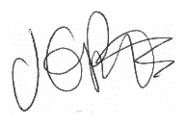

J. Potts
Head Teacher

