21/03/2023

Dear Parents and Carers,

It is with some sadness that I have to tell you that Mrs McArdle will be leaving us at Easter to take up a new job at another school. I’m sure you will want to join me in thanking her for her service to our children over the years and in wishing her well for the future.

Y2 M will have a new teacher after Easter who will be Mrs Warnes. She has worked in our school for a number of years and knows the children well.

Parents’ evening for Y2M will take place on Monday 3rd April, when both teachers will be there so you will be able to meet Mrs Warnes.

Thank you for your support,

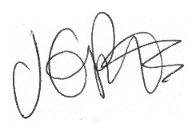

Jacqui Potts
Headteacher

