08/03/2023

Dear Parents and Carers,

As you know, next week there is due to be two days of strike action by one of the teaching unions on the 15th and 16th of March. Our arrangements in school will be slightly different for these days than before.

After doing a risk assessment I can confirm that we are able to open certain classes on those days.

Nursery Foxes – open both days
Nursery Hedgehogs – open Thursday only
Reception D – open both days
Year 1B – open both days

All other classes will be closed for both days.

If your child’s class is open, please order their lunch as normal. If your child’s class is closed and they are entitled to free school meals, you can order a packed lunch to be picked up from school. An order form will be sent home later this week.

Thank you for your support,

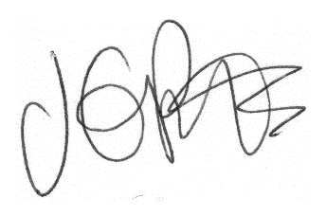

Jacqui Potts
Headteacher

