14/02/2023

Dear Parents and Carers,

Strike day 28th February 2023

Due to industrial action by the National Education Union, our school will be closed to all children on Tuesday 28th February 2023. I cannot guarantee that we will have enough staff members in that day to ensure that all children can be kept safe.

We will be ordering packed lunches for those who are eligible for free school meals, these will have to be ordered beforehand and picked up from the school on Monday 27th February. (An order form for lunch will go out separately to those who are eligible)

I have made this decision earlier than last time because of the half term holiday and wanting to give you time to plan. Should the national situation change during our holiday, I’m not expecting it to, I will let you know if there is a change to this arrangement.

Thank you for your support during these difficult times.

Kind regards,

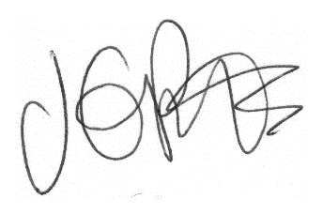

Jacqui Potts
Headteacher

