12th January, 2023

Dear Parents/Carers,

We are delighted to be supporting the NSPCC again by taking part in Number Day on Friday 3 February 2023. Number Day is a great way to make maths fun and bring about a positive, ‘can-do’ attitude!

We are having a fun day of maths activities and will be taking part in Dress up for Digits. Pupils are asked to wear an item of clothing with a number on it or be even more creative by dressing in a maths or numbers theme costume.
As part of our commitment to make maths exciting in our school, we've also decided to take part in a friendly competition involving schools across the United Kingdom. This is a one-day competition which starts on Friday 3rd February 2023 at 07:30 GMT and ends at 19:30 GMT via play.ttrockstars.com.
Children can play in any game mode with every correct answer to a multiplication or division question earning themselves, their class and the school a point. The Times Tables Rock Stars platform will calculate the class average (the number of correct answers per pupil in the class who play during the competition hours, subject to a 60-minute limit). Winning classes in the school, and in the competition as a whole, will be the ones with the highest average.
To help raise money for the NSPCC, we are asking for donations, and we’d love everyone in the school to take part in this special event.
All the money we raise at Mount Carmel will make an enormous difference to children today and help the NSPCC be there for children tomorrow.

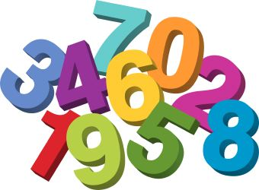
We’re really looking forward to all the fun of Number Day, and we really appreciate your support.

Thank you.

Miss Curran
Mathematics Lead

