Friday 15th January, 2021

Dear Parents/Carers,

As per Government guidance, we are now able to have our Nursery fully open for all our Nursery children. From Monday 18th January, you may bring your child in to Nursery as before. Please drop your child off between 8.30am and 9.00am and collect at the end of the day between 3.00pm and 3.10pm, same arrangements as before. Please be aware that school closes every Friday at 12.55pm to enable teacher’s lesson preparation time and also for school to be deep cleaned.

At this moment in time, we are only able to offer a place in school for your Nursery child, the rest of the school only remains open for children of critical workers or vulnerable children. It is your decision whether you choose for your child to come in to school, it is not compulsory. School is as safe as we can make it, but the decision is yours.

We look forward to seeing you on Monday.

Yours sincerely

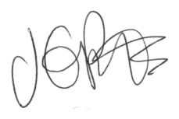

J. Potts
Head Teacher

