6th January 2021

Dear Parents/Carers,

Due to the high demand for places our spaces are completely full.

We understand that parents want the best for their child’s education, but we are now asking that if you are a family that has a keyworker but also somebody at home who is currently not working or furloughed, can you consider keeping your child at home and releasing their place?

Please contact the office if you feel that you can release your child’s place. We thank you for your understanding and co-operation during this critical time in the pandemic.

Thank you for all your support.

Take care and stay safe.

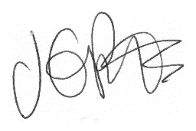

Jacqui Potts
Headteacher

