Wednesday 21st September, 2022

Meet your child’s teacher!

Dear Parent/Carer,

On Tuesday 27th September, there will be an opportunity for parents/carers to meet your child’s teacher at either 4 pm or 5 pm at both Infant and Junior Departments. The meeting will take place in your child’s classroom. There will be a small presentation initially, followed by an opportunity to ask questions if necessary.

Please do not bring your children with you to the meeting, this is for parents/carers only.

You do not need to book on, or let us know if you can or cannot attend. Please just turn up at the time that is most convenient for you.

We look forward to seeing you on Tuesday. If you are unable to come along, there is always lots of information for you to look at on the school website on the individual class pages.

Yours sincerely

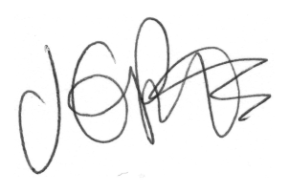

J. Potts
Head Teacher

