12/09/2022

Dear Parents and Carers,

Following the death of Her Majesty Queen Elizabeth, a period of national mourning has started and will end after the state funeral on Monday 19th September 2022. As a mark of respect our school will be closed on this day as it has been designated a bank holiday.

This is a period of great historical significance for our country and coming so soon after the joyous celebrations of the platinum jubilee, the children are aware of who the Queen was and of the events in her long reign. As is our tradition as a Catholic school, we will be praying for her and for our new king.

Thank you for your ongoing support for our school.

Yours sincerely,

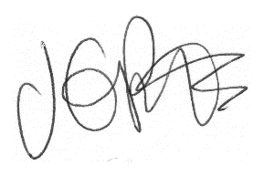

Jacqui Potts
Headteacher

