18th September 2020

Dear Parents/Carers ,

We are launching Times Table Rock Stars on **Friday 25th September.** Some pupils started to use this APP during lockdown and now we’re back in school, we’re going to officially launch it with a day of number fun!

To launch this we are having a Rock Star Maths Theme Day. The children are to come in dressed as a Rock Star in jeans and a t-shirt and maybe a funky hairstyle! **(Please ensure children in KS2 wear their trainers as they will still be doing P.E).**

We will also be having a themed lunch. As it is a Friday it will be a meat free menu. We will have….

Veggie Burgers

Veggie Hotdogs and Onions

Onions Rings

Fries

Milkshake

Number Biscuits

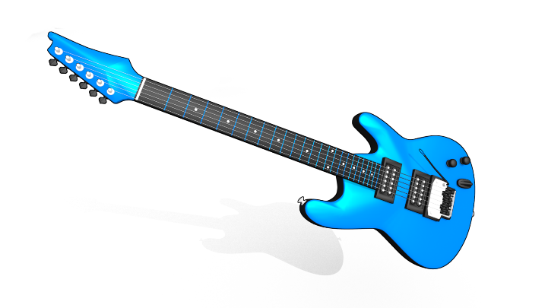If you child normally has a packed lunch but would like a school meal on this day, please ring or email the office by Tuesday 22nd September and pay £2.20 on ParentPay.

We look forward to rocking the day away!

Mrs Seaborn

Deputy Headteacher