09/09/2020

Dear Parents,

We have noted concerns with regard to safe pick up at the end of the day in the Junior Department and we are going to implement the following system:

Year 6 Parents 3pm - 3.10pm
Parents line up on the right side of the gate towards Old Road.

Year 5 Parents 3.10pm - 3.20pm
Parents line up on the left side of the gate along the fence.

Year 4 Parents 3.20pm - 3.30pm
Parents line up across the road along the church wall.

Year 3 Parents 3.20pm - 3.30pm
Parents line up along the fence to the left of the steps.

A member of staff will direct you, please work with staff. Please be mindful of social distancing and please wear a mask.

There is a 10 minute window of time for you to arrive to pick up your child. If you pick up more than one child, please join the back of the queue accordingly.

We are working hard to keep your children safe and we need you to work with us to do the same. Our exit points are limited so please be patient with us and we will return your child to you as quickly as possible.

Thank you all for your continuing support!

Yours Sincerely,
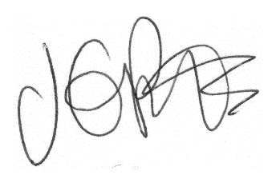

Jacqui Potts
Headteacher

