03/09/2020

Dear Parents,

What a fantastic sight it was this morning to see all the children’s happy faces, eager to get back in to school.

I want to thank you all for the work you have done with our young people over the lockdown period and congratulate you all on surviving home school. We are very excited to welcome the children back and to take over from you.

Many of you may have been a bit anxious to send your children back, I can only assure you that we have worked hard to make school as safe as we can while making it still recognisable as our Mount Carmel.

As before, we are still being given up to date advice on how to be safe and if anything is to change I will let you know. During these first couple of days and weeks, as we get used to being back, I ask for your patience and understanding in all things – we may have to change how we do certain things but there will be a reason for doing this and hopefully any changes will be for the better.

Thank you again for trusting us with your most precious children, we will do our very best to look after them, I promise!

Best wishes,

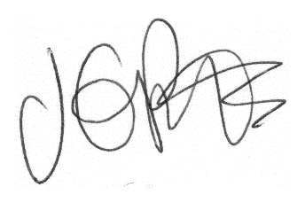

Jacqui Potts
Headteacher

