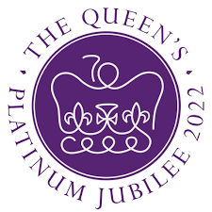
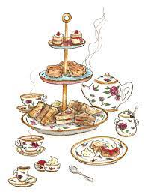
Friday 6th May, 2022

Dear Parents/Carers,

Celebrating the Queens Platinum Jubilee
On Friday 27th May, we will be celebrating the Queen’s Platinum Jubilee in school by having a special ‘afternoon tea’ during lunch time. The children will have finger sandwiches, cakes and strawberries and cream and hopefully, if the weather is kind to us, this will take place outside in the sunshine! There will also be other special activities taking place during the day!
If your child normally brings a packed lunch from home but you would like them to have the ‘afternoon tea’ provided by school, please contact the office by email or phone call by Monday 16th May, as we would need to know extra numbers in advance for catering purposes. The charge for the afternoon tea will be the cost of a school lunch which is £2.20 and payments will be required via Parentpay. (There is no charge if your child has an underlying entitlement to free school meals, or if your child is in Reception to Year 2 and therefore entitled to Universal free school meals).
We look forward to it being a lovely last day of half term for all to enjoy!
Yours sincerely
J.Potts
Head Teacher

