27/04/20

Dear Children and Families,

We hope you are all keeping safe and well and you have enjoyed the sunshine this weekend. We are missing your smiling faces.

We have changed the home learning for the upcoming weeks. This work has been set by the class teachers for Reception to Year 6. You can find this work by going onto the school website http://www.mountcarmel.manchester.sch.uk/ .You do not need to log onto school spider.

Once you are on the website select- Home learning and then select -Summer Term Week 2 Home Learning

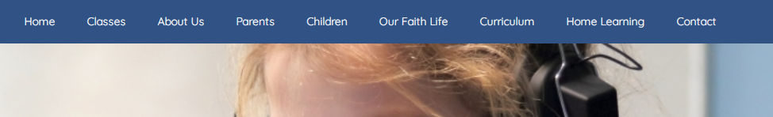
If you are accessing the website through a mobile phone or tablet it will look slightly different. Select the MENU icon at the top and drop down to Home Learning. Press the arrow at the side and you will be able to select Summer Term Week 2 Home Learning. It may look like this
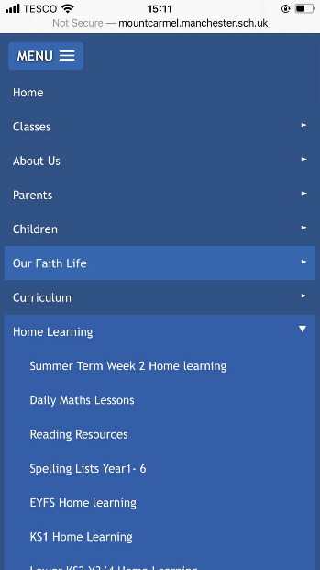

The teachers have left a message for their class with the work. During this period of school closure, if you wish to email the class teacher a picture of your completed work they would love to see it. Teachers have put their email addresses with the work. Please send emails within school hours. If you struggle to access the work on the school website, please contact school and we will help.

For children in Nursery and Reception there are resources, videos and activities on the Tapestry page. If you do not have log in details or they need resetting please email Mrs Walley and she will sort this out for you. K.Walley@mountcarmel.manchester.sch.uk.

There are other websites we recommend

https://www.bbc.co.uk/bitesize/learn
https://whiterosemaths.com/homelearning/
https://www.tentenresources.co.uk/primary-subscription/prayers-for-home/sunday-liturgy-for-families/
https://www.tentenresources.co.uk/daily-prayers-for-home

Lots of love your Mount Carmel Family x

