Thursday 26th March, 2020

Dear Parents/Carers,

Free School Meal Entitlement/Hardship Grant
Dear Parents/Carers,
Apologies for the delay in sending this information but we have been waiting for clarification from the Council and for the link to go live. If you are entitled to Free School Meals, Manchester City Council are providing a voucher scheme in which they will send you a voucher to print, a pin code to your phone or a bank transfer. Unfortunately it will be a few weeks until this is up and running. Until then, if you are struggling with food costs, please click on the link below and apply for a hardship grant.
Take care everyone.
https://secure.manchester.gov.uk/info/200008/benefits_and_support/6302/apply_for_a_cash_grant_if_you_are_in_financial_crisis

Yours sincerely
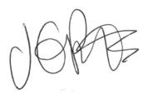
J. Potts
Head teacher

