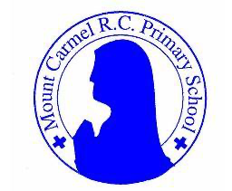

Home Learning
INFORMATION FOR PARENTS

Why have Learning Projects been created?

Learning Projects have been created as a result of schools shutting due to the Coronavirus outbreak across the UK. Based on this very real and increasing threat a decision was made, by Robin Hood Multi Trust Academy, to pool a number of curriculum and year group experts to write a set of home learning projects which can be completed by your child in the event that schools are closed for a set duration. In creating the Learning Projects it was fully acknowledged that they cannot replace the quality of learning your child receives at school however, the complete focus was to create a set of projects that all children can access to maximise their learning whilst at home. Robin Hood Multi Trust Academy have very generously shared their resources with school throughout England and we have adapted them to fit our curriculum at Mount Carmel.

What are the aims of the Learning Projects?

- To create age specific learning opportunities for primary school children.
- To create a resource for parents that is easy to access and use - the focus is on parents being able to help deliver the content or children accessing it independently.
- Key learning is linked to the National Curriculum.
- To enable children to continue with their learning at home during an enforced shutdown.
- To enable families to focus on a joint topic and theme to promote family wide learning.
- To provide structure and focus to each day that an enforced shutdown occurs.
- To centralise online learning resources and links into an easy to manage format for families.

How do I use the Learning Projects?

As a parent your first step is to go to the website http://www.mountcarmel.manchester.sch.uk/ And select home learning and then the key stage linked to the year group your child is in. At the moment, the first week of projects is available and more will be added over time. There will be seven weeks worth of projects that are available. You then download the project and begin following it. The aim is for you to complete a minimum of two hours of learning a day with your child but this is very much your parental choice and you may wish for your child to do more.

What happens if my child finds the learning too difficult?

Our first piece of advice to parents is that ALL children find elements of learning challenging at times so try not to worry if your child becomes stuck and you cannot explain it to them. If this happens then make a note of what they found hard and move onto another learning activity - the school will cover any misconceptions when we return.

The Learning Projects which have been designed are based on the National Curriculum expectations for the year group which your child is in. It may be that your child finds the tasks set within the Learning Project for their year group too challenging, for example if they have additional learning needs. If this is the case, then we advise that your child accesses the Learning Projects which are set to the age range below, for example a child in Year 3/4 could attempt the KS1 Learning Project, if this is more appropriate for them.

The Learning Project Overview

The Learning Projects have been created so that across the different Key Stages, children are studying based on the same theme each week. This should ease and support family learning. In Week 1, the project is based around My Family and continues with projects based upon The Area You Live In, Viewpoints, Animals, Environment, Food and Celebrations. Week 2, has already been uploaded onto the school website.

How have Learning Projects been created?

Specialist curriculum designers from across the Robin Hood Multi Academy Trust were brought together to create the Learning Projects. Within the team of specialists there was expertise in all age ranges at a primary level along with a wide level of expertise in all curriculum subjects covered within the Learning Projects.

We hope you have fun working on the projects.

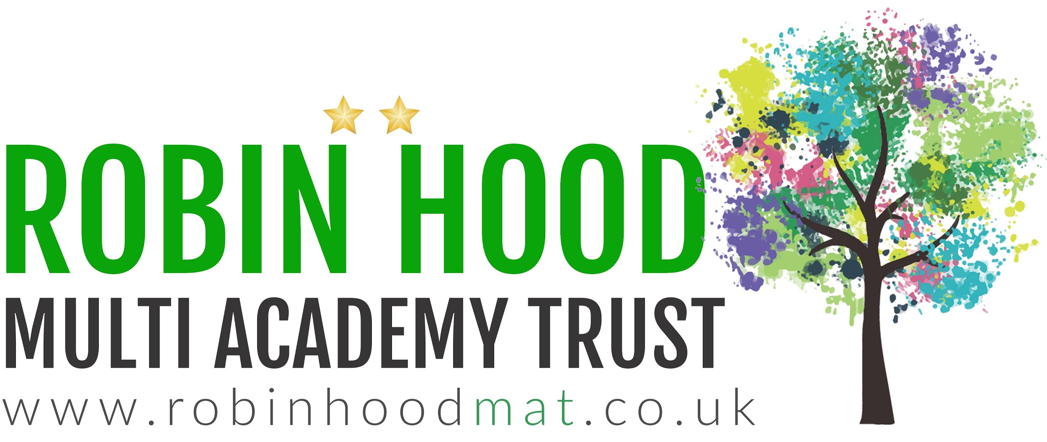

Other Resources
Children can also access the school’s Espresso subscription which offers a wealth of flexible resources. Log in at www.discoveryeducation.co.uk Username- student3061
Password-mountcarmel

Oxford owl have a range free eBooks collection, developed for children aged 3–11 years old. All you need to do is register to access these free books
https://www.oxfordowl.co.uk/for-home/find-a-book/library-page/

Phonics play is free to use during this period.
https://www.phonicsplay.co.uk/ Username- march20 Password- home

