26th March, 2024

Dear Parents/Carers,

We are writing to inform you of a price increase that is happening with your children’s school meals. From 1st April 2024, Dolce are increasing the price of school meals to £2.75 per day.

Dolce have informed us that unfortunately due to the current economic situation this is unavoidable. Dolce state ‘that the increasing levels of food inflation, reaching at some points in the year over 19% has presented our biggest challenge but we are pleased to see those unprecedented levels beginning to ease with percentage increases now being much lower. The latest annual CPI inflation figure for food (and non-alcoholic beverages) at the time of writing this letter is 9.2% (up to November 2023). You will also be aware that the National Living Wage will increase by 9.8% to £11.44 in April 2024. We do, of course, continue to work hard to reduce the impact of cost increases through negotiations with our suppliers and future plans to keep future price increases as low as we possibly can.’

As a School, we appreciate this is a difficult time for everyone as costs are increasing everywhere. We are grateful as always for your understanding and continued support.

Yours sincerely
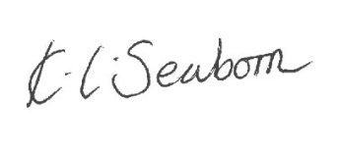
K. Seaborn
Headteacher

