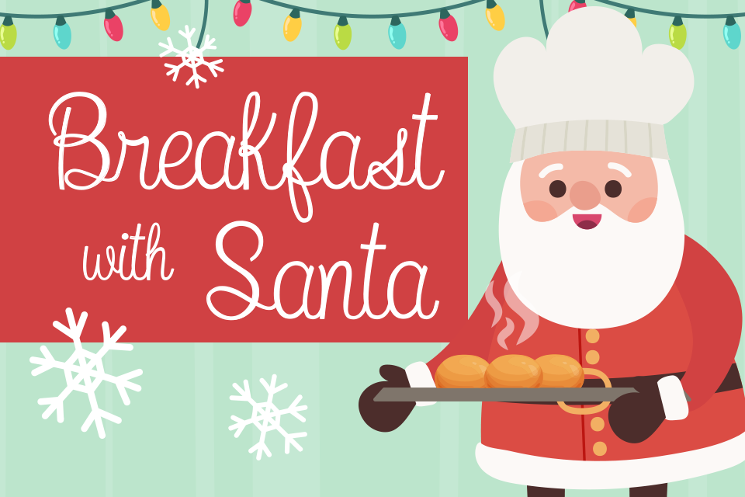
Dear Parents and Carers,
The PTA are pleased to announce that we will be holding Breakfast with Santa events during the last week of term. Breakfast with Santa will take place in year groups and each year group will have a different day for their breakfast.
Monday 18th December- Reception
Tuesday 19th December- Year 1
Wednesday 20th December- Nursery
Thursday 21st December- Year 2
The breakfast will start at 8.15am and after the event children will be taken to their class for their usual day (unfortunately parents will not be able to stay).
Tickets cost £3.50 and children will receive a gift from Santa and a small breakfast (fruit juice, croissant and a piece of fruit). Santa will also read the children a Christmas story on his visit.
If you would like your child to attend, please put £3.50 in an envelope with your child’s name on, their class and write Breakfast with Santa on the envelope then send it into school.
Please send in the money before Wednesday 13th December so we can cater and plan correctly for the event!
Children can wear a Christmas Jumper on the day of their breakfast.
Thank you for your continued support,
Mount Carmel PTA

