Curriculum Enrichment 2022-2023

Nursery
Asda
Nursery walked to Asda to buy the ingredients to make porridge. We saw lots of familiar items on the shelves and used our shopping lists to help us find the items we needed. We paid at the till and helped to out the shopping into a bag. A brilliant first trip out!
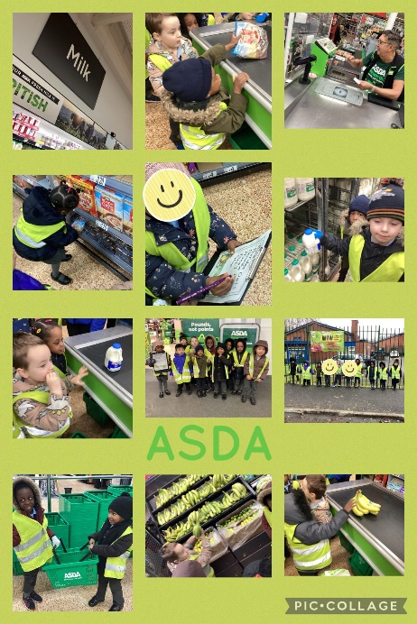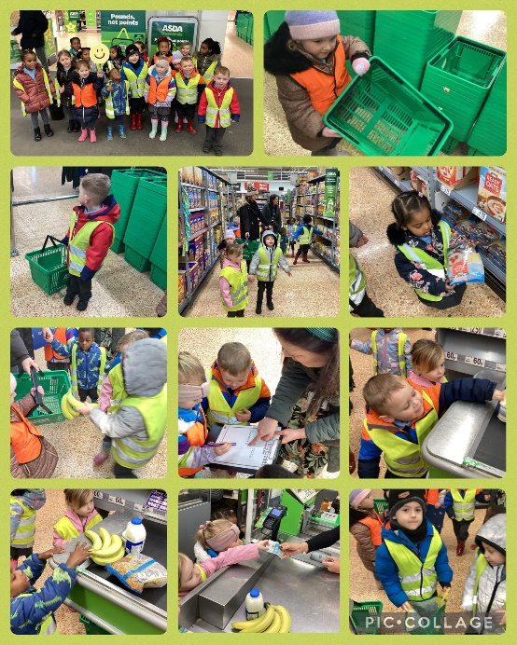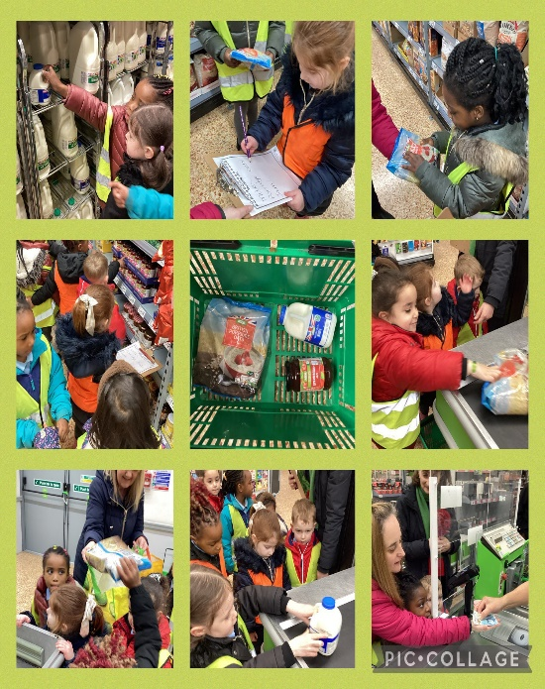
Traffic Observation
Nursery went out to observe traffic in the local area. We had to look for cars, buses, lorries and motorbikes. We did a wonderful job and we saw lots of different types of transport.
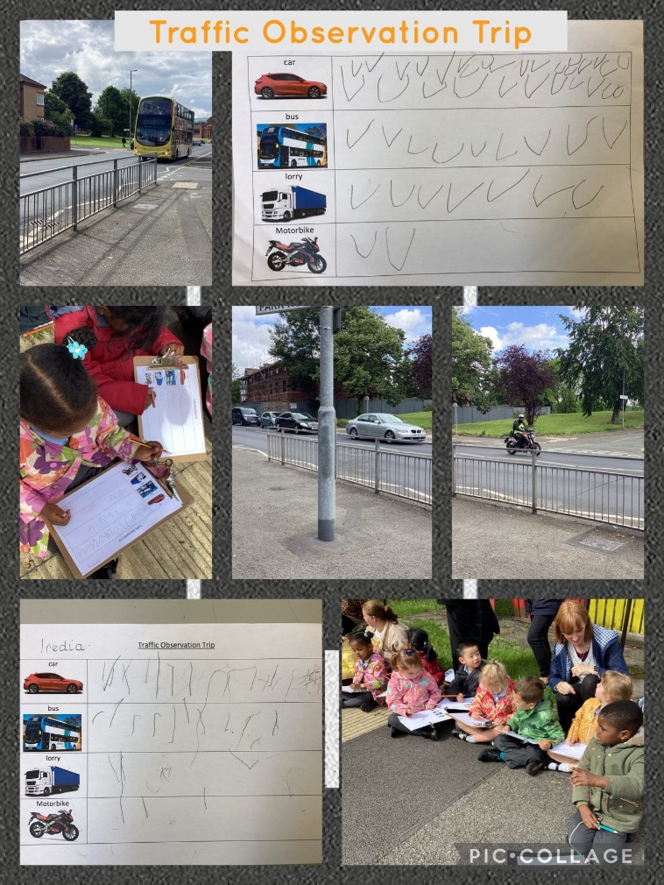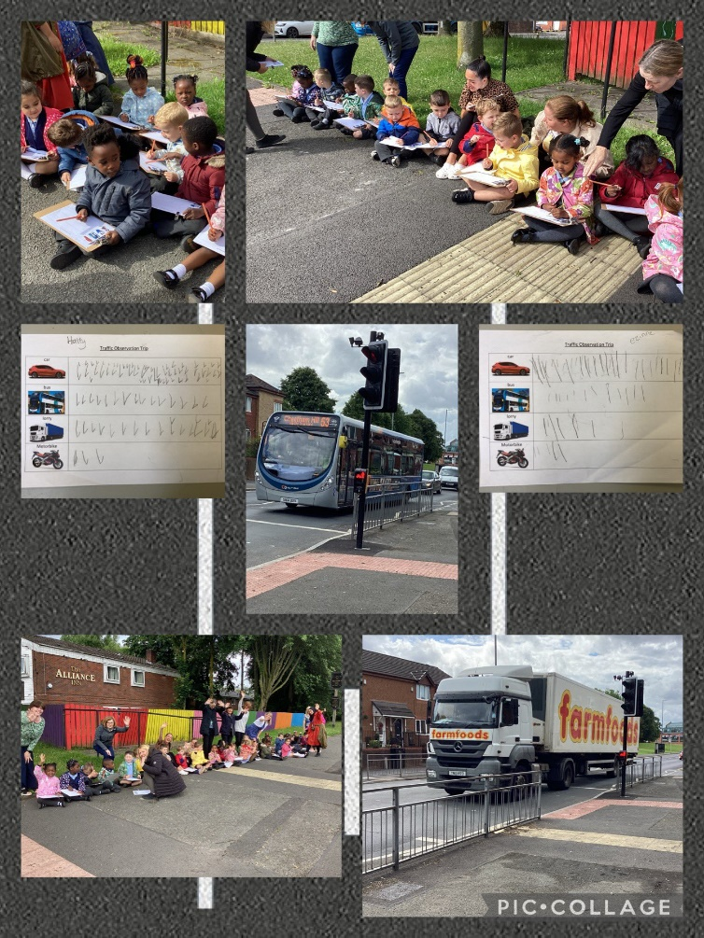

Reception
Grandparent Visit
Reception had a visit from Nana Seaside. She came to talk to us about her life when she was a little girl. She shared some pictures from her past with us and we looked at the toys she used to play with. She showed us how to play 2 ball.
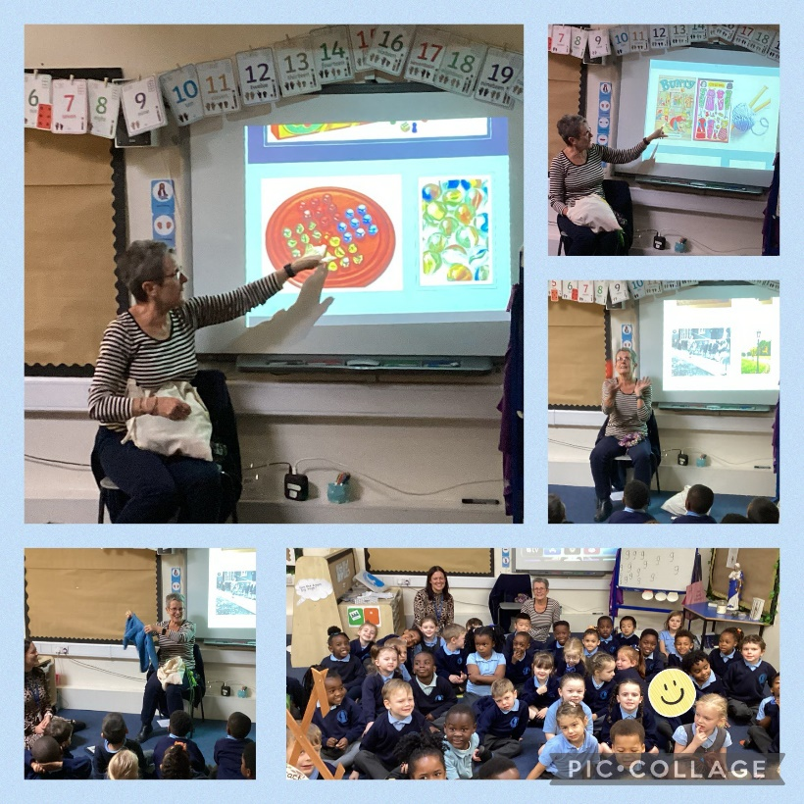
Geography Field Trip
The children have been learning about different types of houses. We looked at pictures of our own houses and then went for a walk in our local area to spot the different types of houses and buildings. We worked together to write the houses we found.
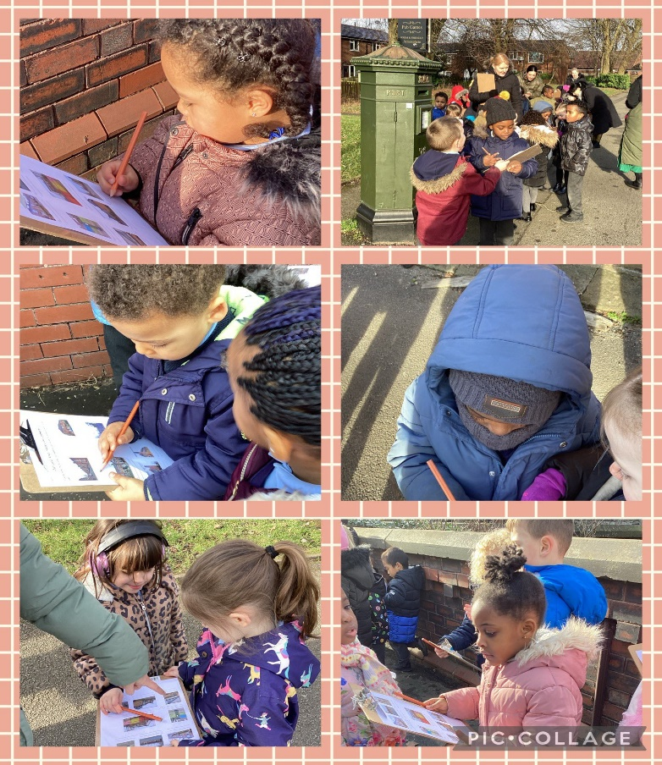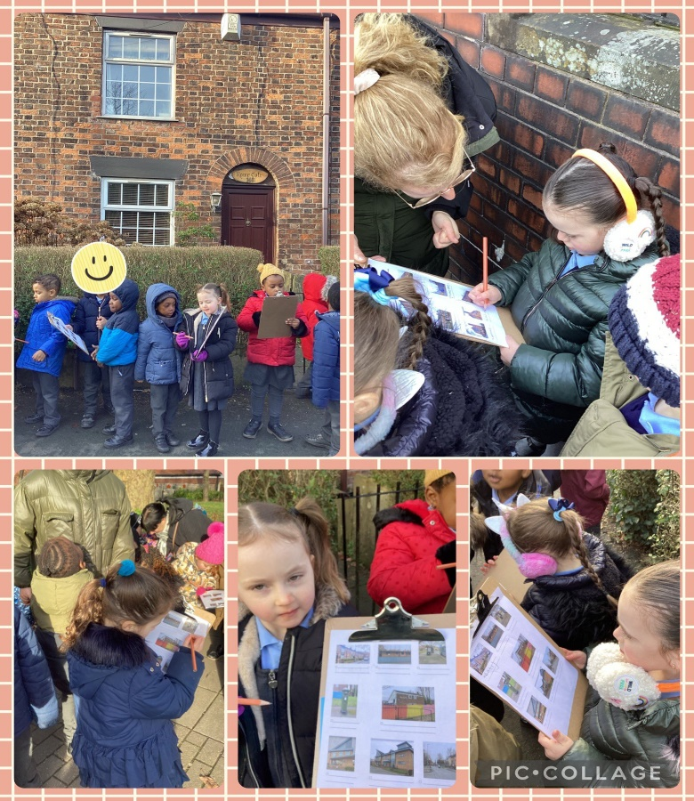

Library Visit
The Reception children enjoyed a visit to the library. Ilaria Passeri took the children on a magical adventure to Honey Pot Village. The children then created their own characters. When we got back to the classroom, the children drew their characters and wrote about their characteristics.
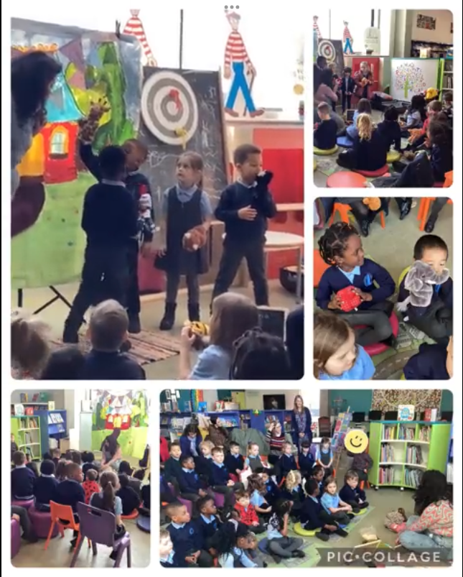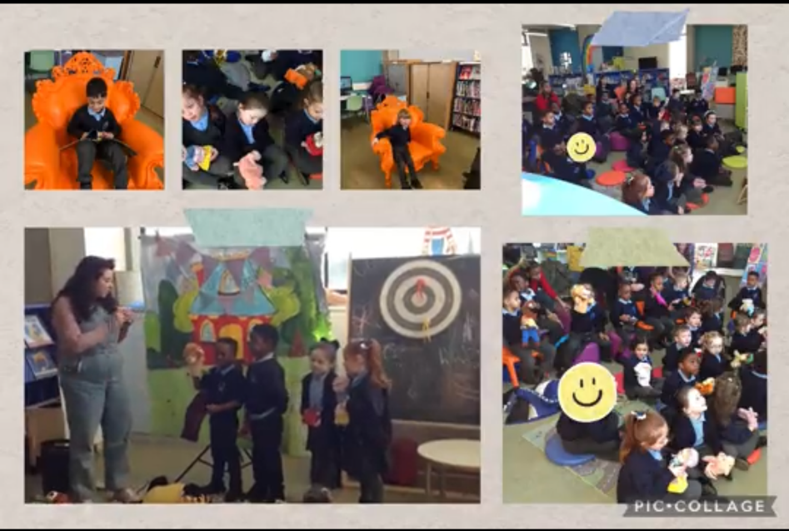
Manchester Oral Health Team
We had a lovely visit from the Manchester Oral Health team. We learnt all about keeping our teeth healthy and how to brush our teeth. We even got to take a new toothbrush home. The children enjoyed role playing being dentists after the visit.
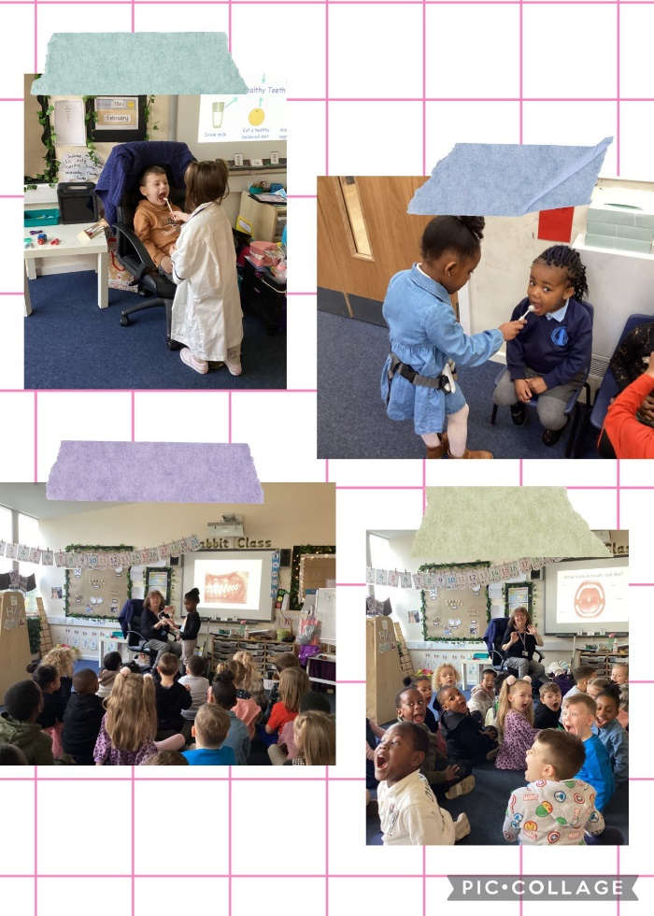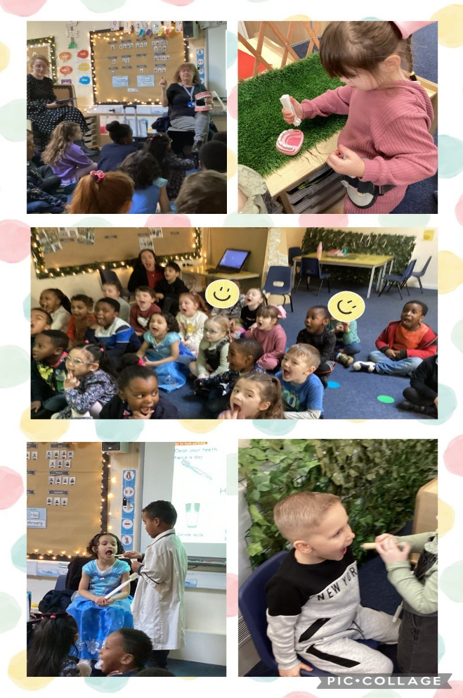

Year 1
Blackpool
Year 1 had a fantastic trip to the seaside as part of their history and geography topic looking at Blackpool’s famous landmarks and why tourists visit Blackpool. We went up Blackpool Tower and watched some ballroom dancing whilst eating our lunch.
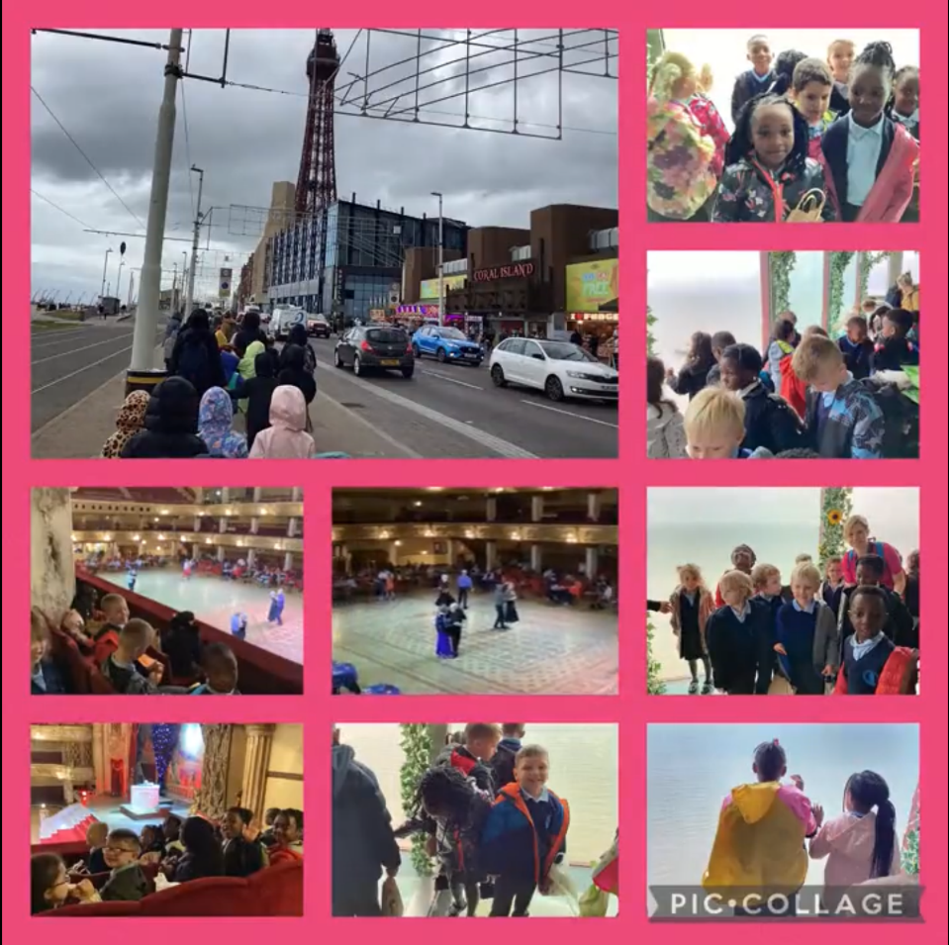

Year 2
Angel War Memorial
As part of our Remembrance topic in History, year 2 went to Boggart Hole Clough to visit The Angel War Memorial. We laid our poppy wreaths, said prayers and paid our respects. We looked at different features of the memorial to investigate ‘Why is it important to remember?’.
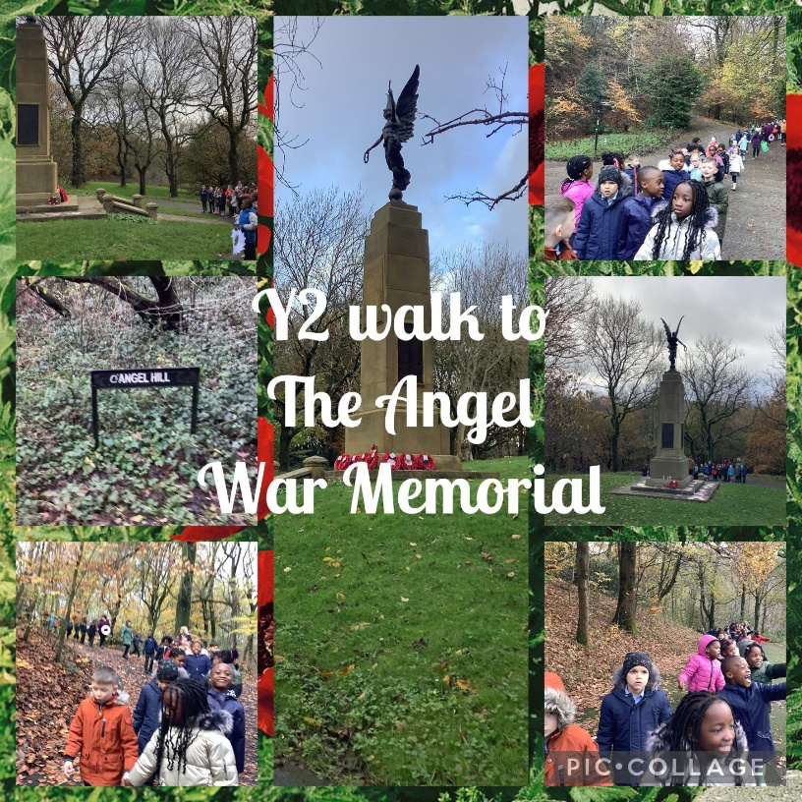
Clifton Country Park
Year 2 loved our trip to Clifton Country Park to see the amazing fairy tale sculptures as part of our art topic this term. We even found the Gruffalo! We can’t wait to make some of our own.
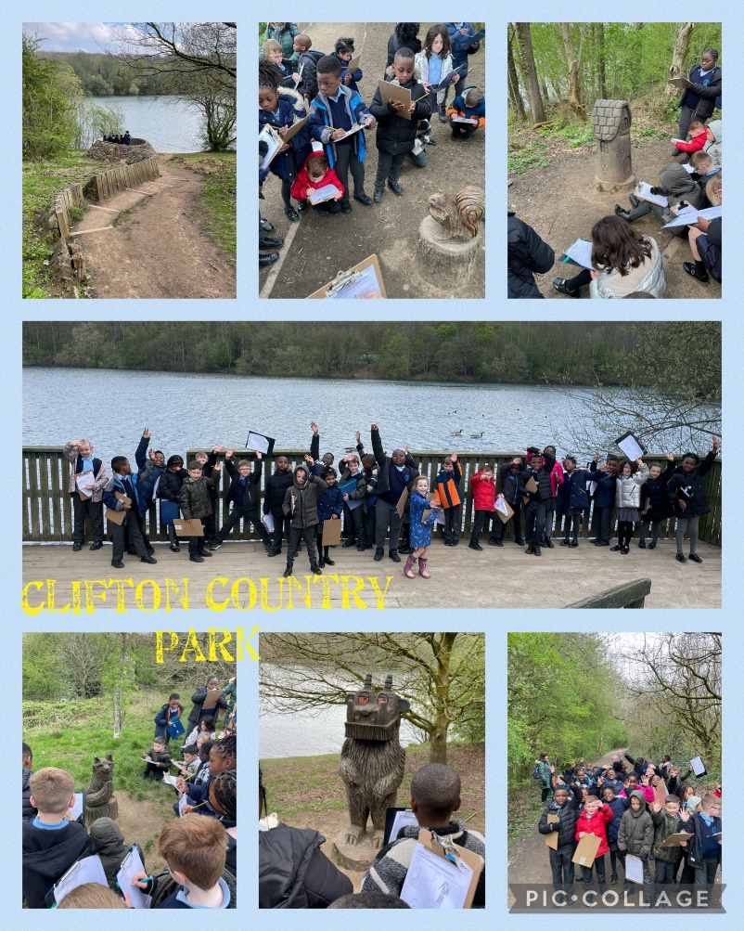

Aspirations Week
During Aspirations Week, we have been talking to the children about aspirational people and different jobs. It was lovely to have a visit from the fire service. They spoke to the children about their training for the job and the different jobs they do.
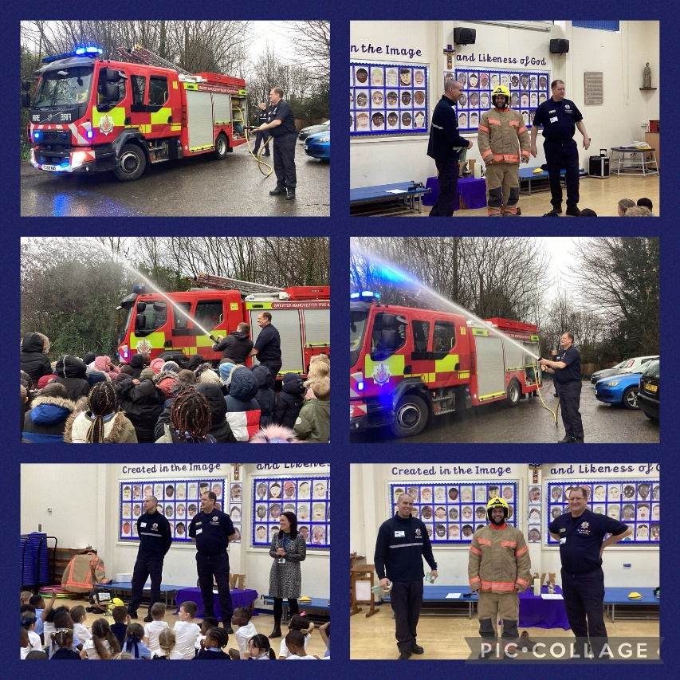

Year 3
Pizza Express
Year 3 visited Pizza Express as part of our D&T topic on pizzas. We travelled to and from Manchester on the bus – we were very sensible! We learnt how pizzas are made and about the ingredients needed. They tasted amazing!
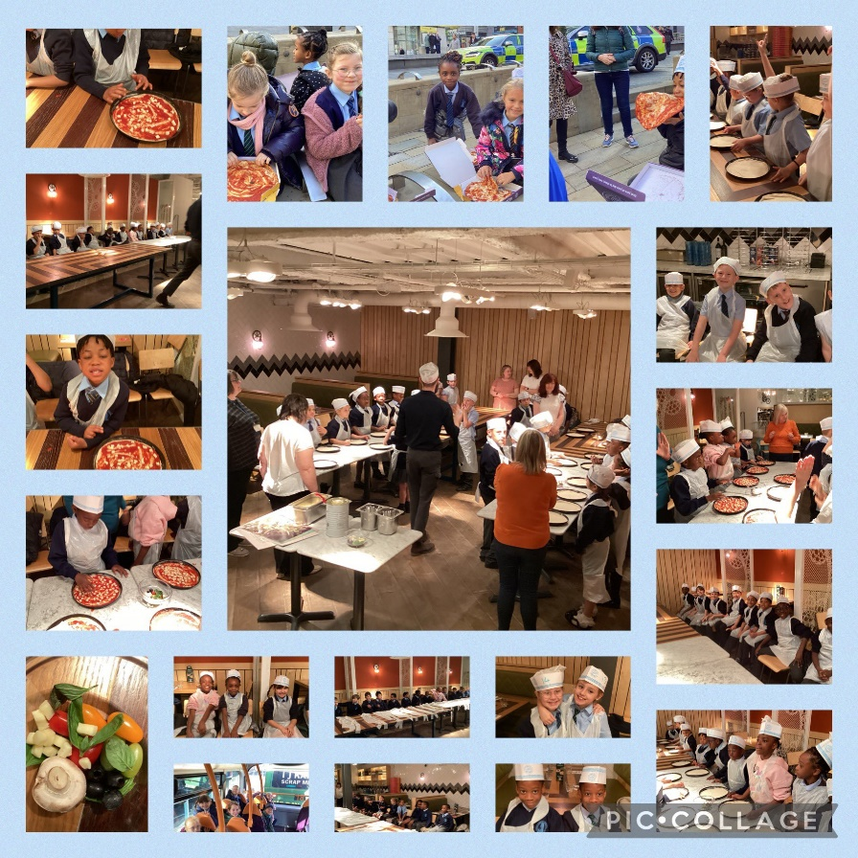
Manchester Jewish Museum
Year 3 had an amazing afternoon out at the Manchester Jewish Museum. We learnt about special objects of Judaism, looked at artefacts in the museum and created a film all about the synagogue.
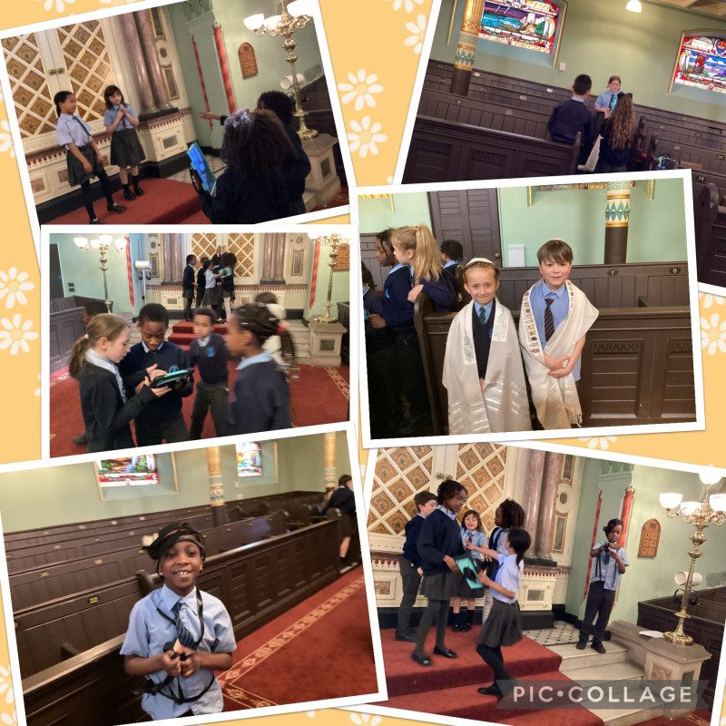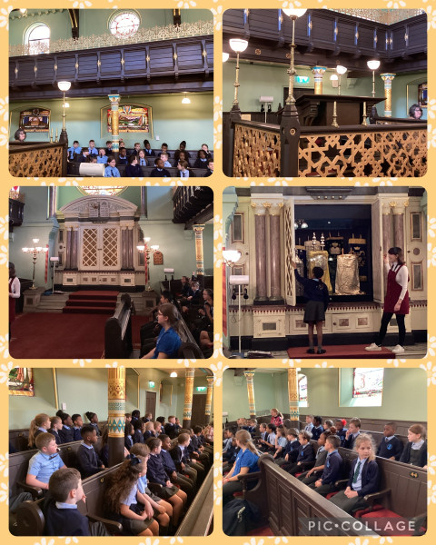

Year 4
Electricity
Year 4 had an amazing day with Creative Builders Workshop. We build a Lego city and used our knowledge of circuits to light our buildings up.
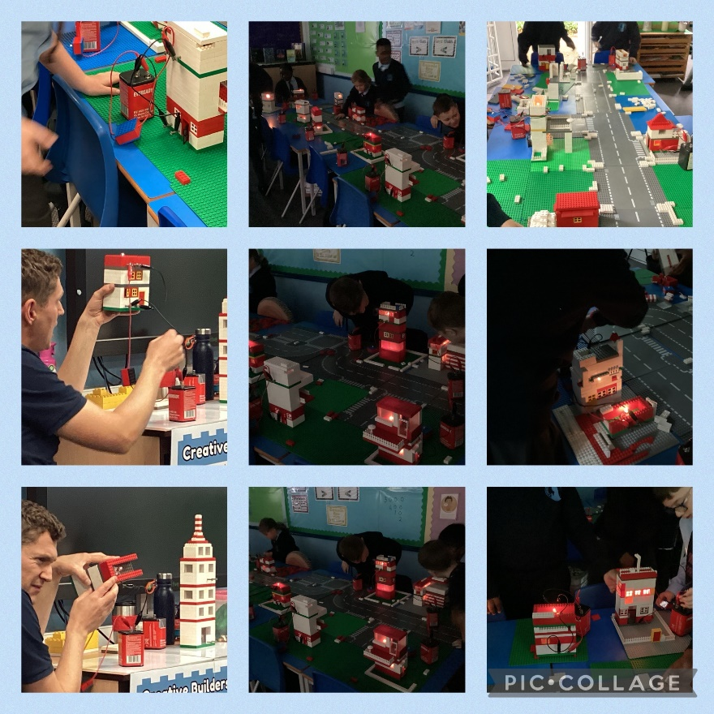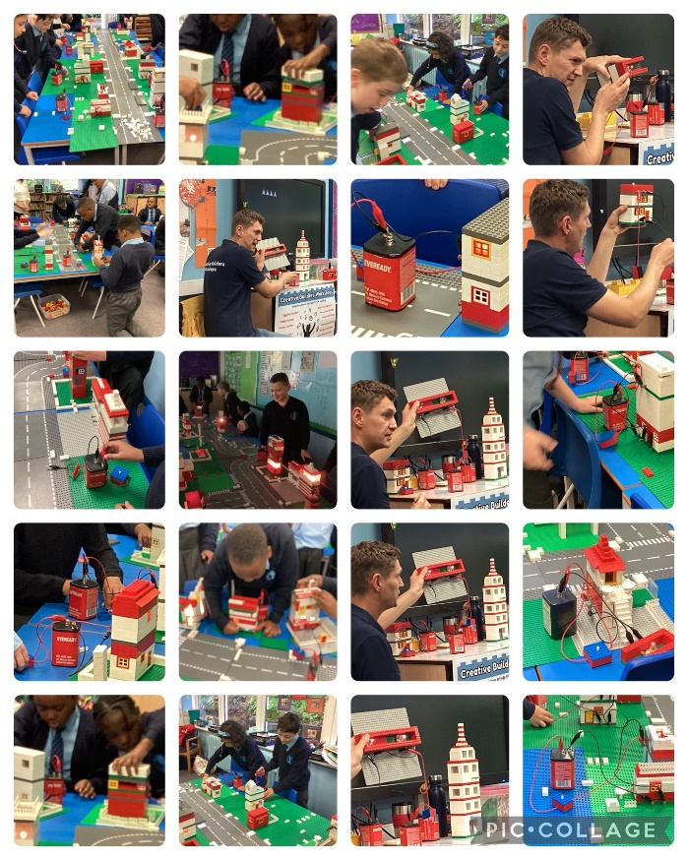
Sound
Year 4 had an amazing time taking part in a sound workshop. We learnt about how sound travels and we tested many different musical instruments. Thank you Sam!
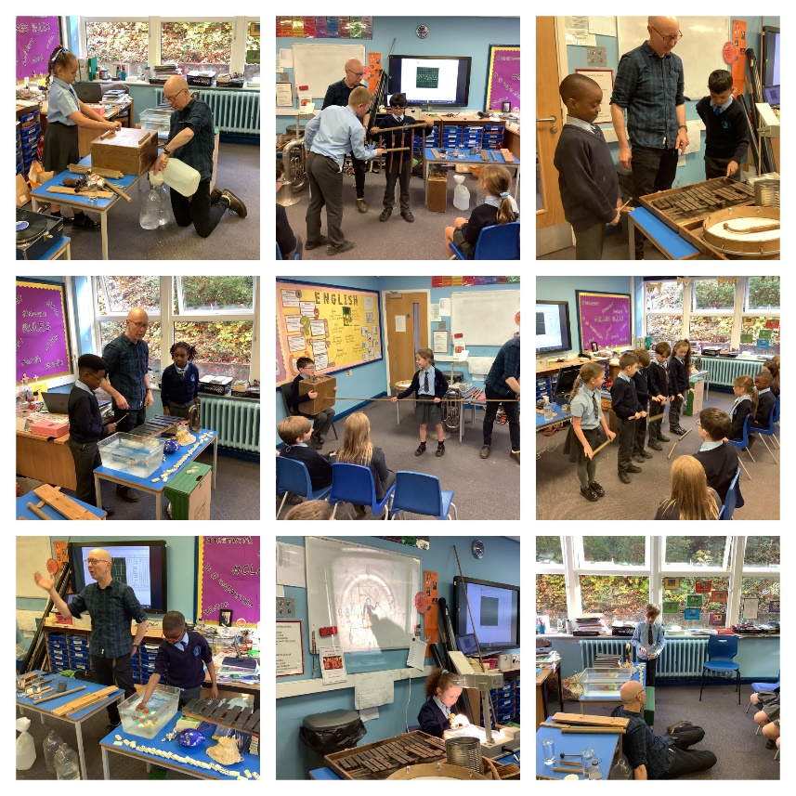

Bolton Abbey
Year 4 had a fantastic day at Bolton Abbey looking at rivers for our geography topic. It was a beautiful day, we even got to see the ruins of Bolton Abbey.
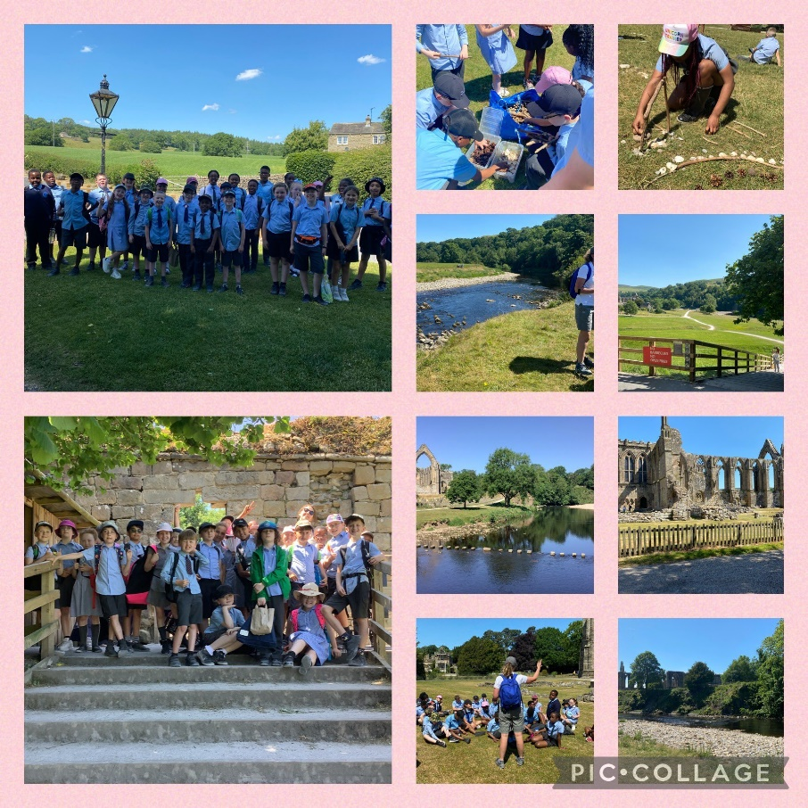

Year 5
Anglo Saxons
Year 5 had a fantastic day learning all about Anglo Saxons with Mr North from Time Trips. We looked at some Anglo Saxon artefacts and then made our own shields and helmets. We also learn about Anglo Saxon jewellery and even made our own!
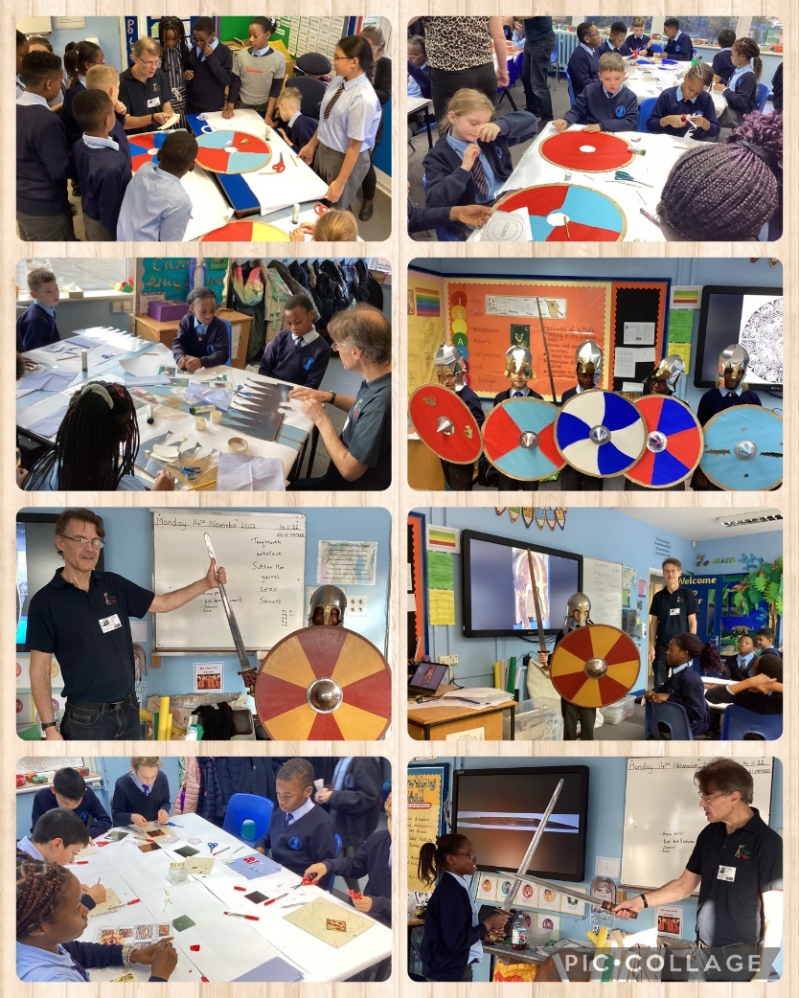
Bikeability
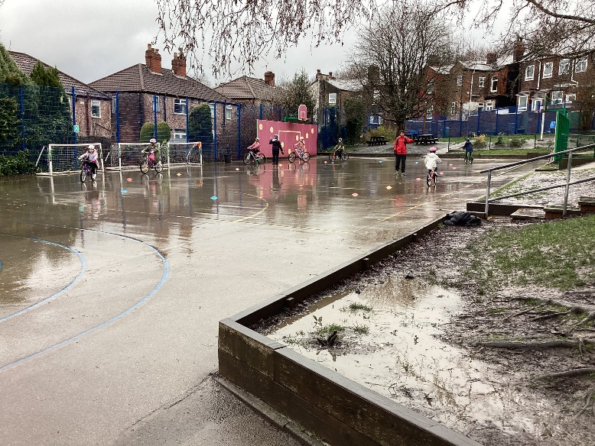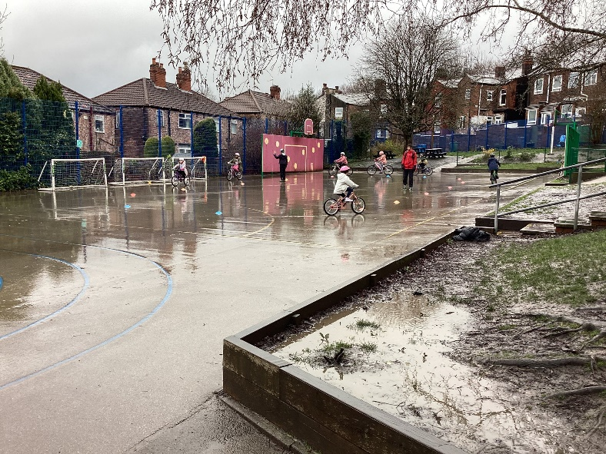
Heaton Park Astronomy Group - David Bell
Year 5 were very lucky to have a visitor from the Heaton Park Astronomy Group, David Bell. He shared all of his knowledge about space with us. It was amazing, we had so many questions.
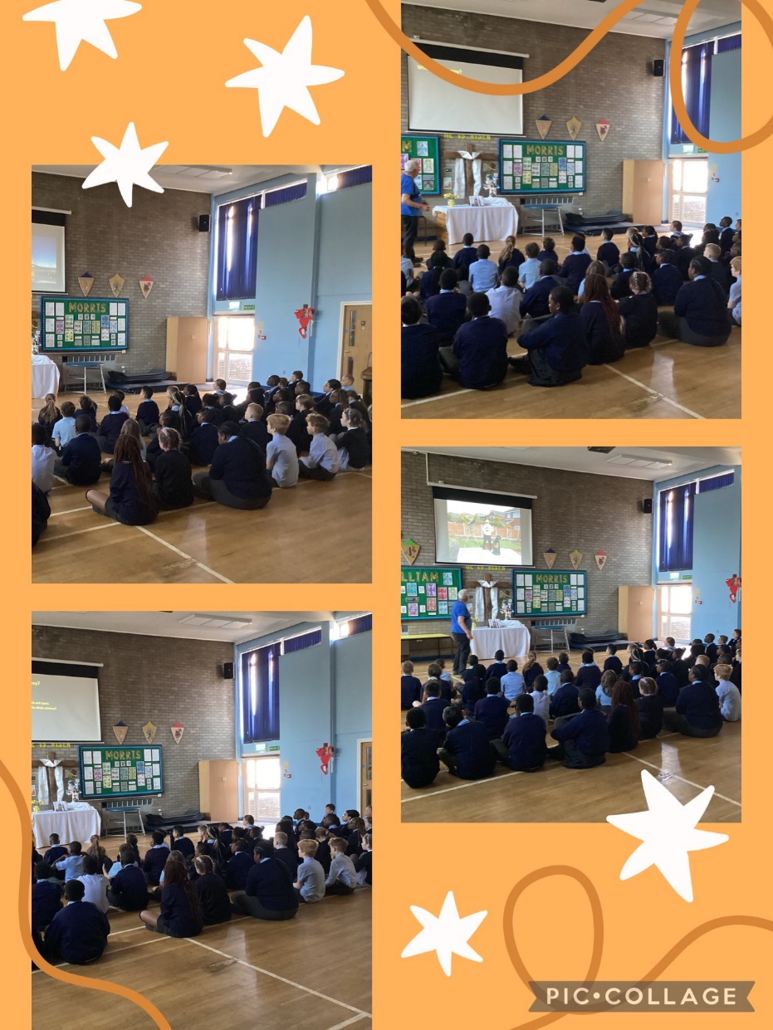

Rockets
Year 5 had a fabulous day designing and making rockets for D&T with Amanda Morrow from Discover and Create. We made our own rockets out of milk bottles, pop bottles, pipes and fruit shoot bottles and used them to launch our rockets into the sky!
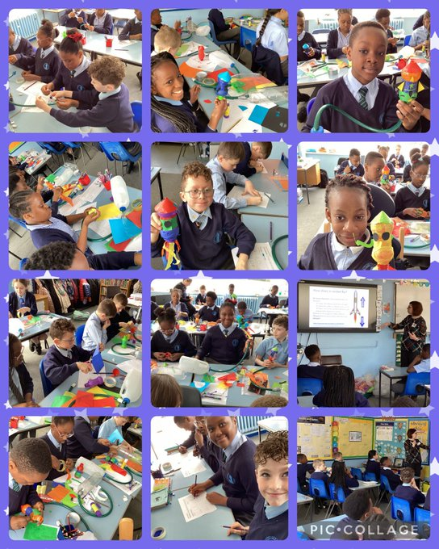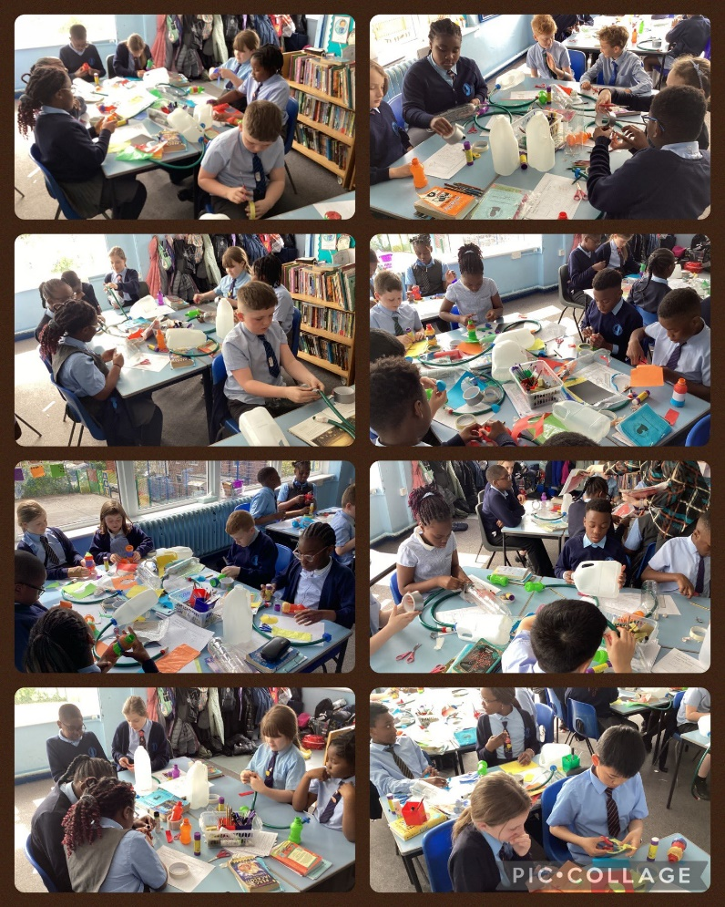

Year 6
Manchester Central Library
Year 6 had a fabulous time at Manchester Central Library. We met the fantastic author Hannah Gold and she talked to us about her books and inspirations. We’ve been enjoying ‘The Last Bear’ in class and it was a privilege to meet her. We gave her a collection of our versions of Chapter 9 and she gave us signed copies of her books.
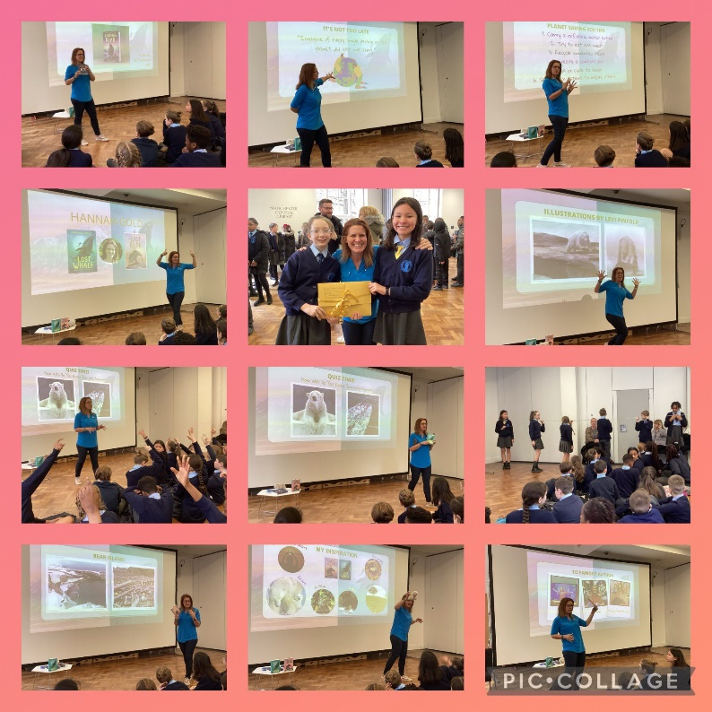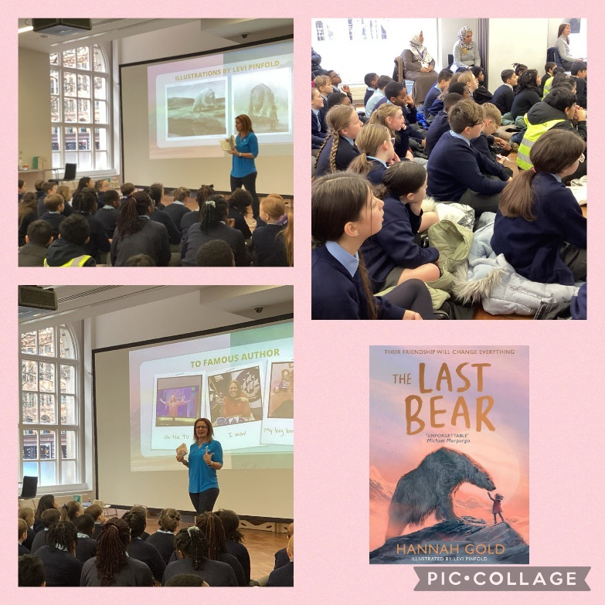

Peterloo Massacre Memorial
Year 6 visited the Peterloo Massacre Memorial. We have been learning about that day in history and wanted to pay our respects to the people involved.
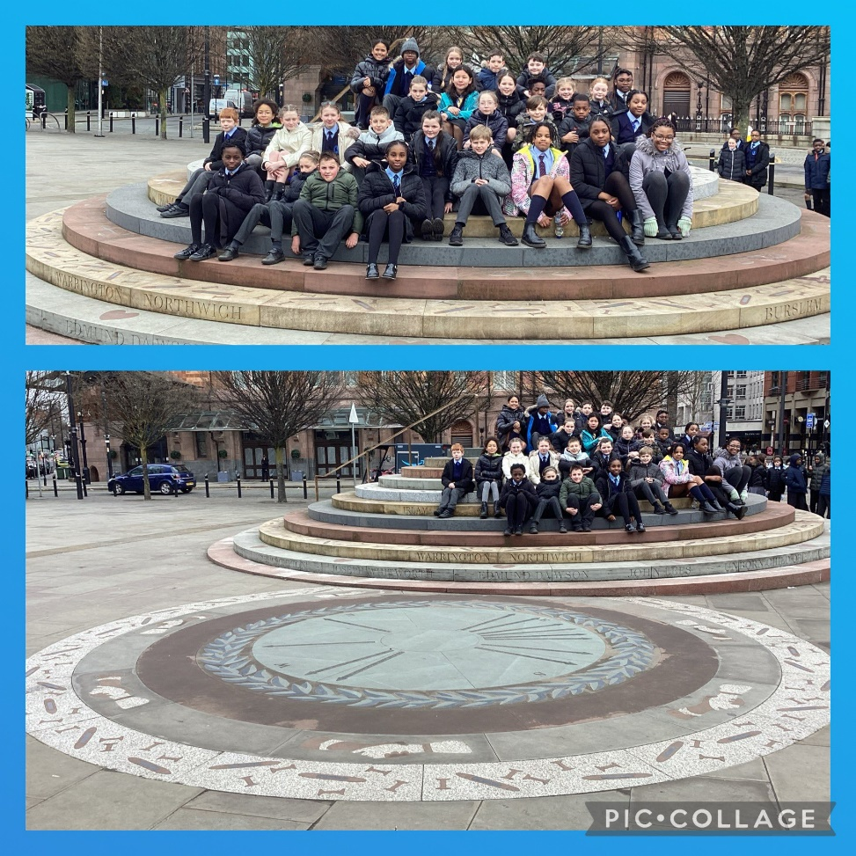
KPMG
Year 6 travelled into Manchester to spend the day with KPMG and The Economist Educational Foundation. We looked at how numeracy is important in the news and analysed statistics to discuss how the internet is used. Our favourite part of the day was the office tour including the balcony view of Manchester.
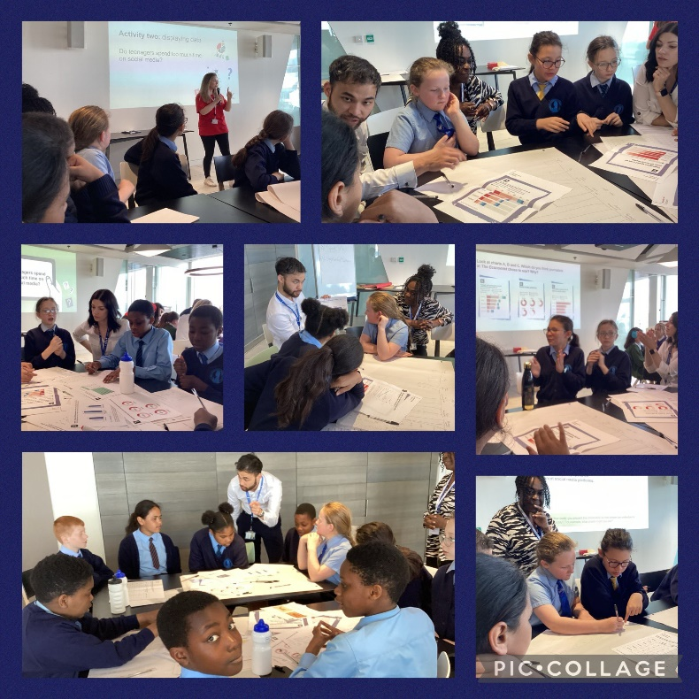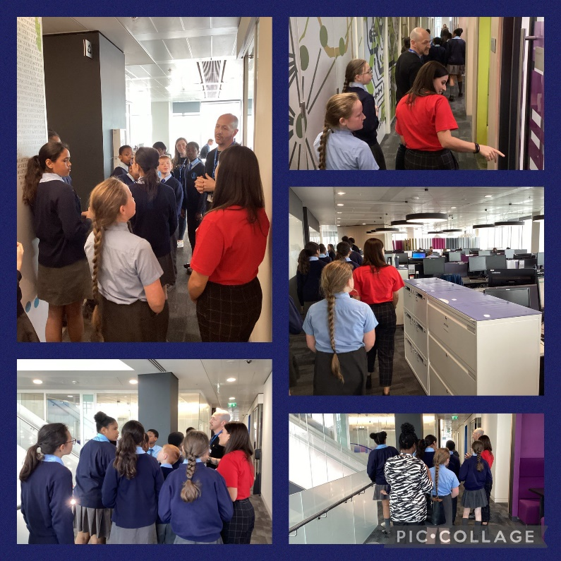

Geography Field Trip
Year 6 really enjoyed carrying out a survey about road use in our community in our geography topic ‘Local Fieldwork’.
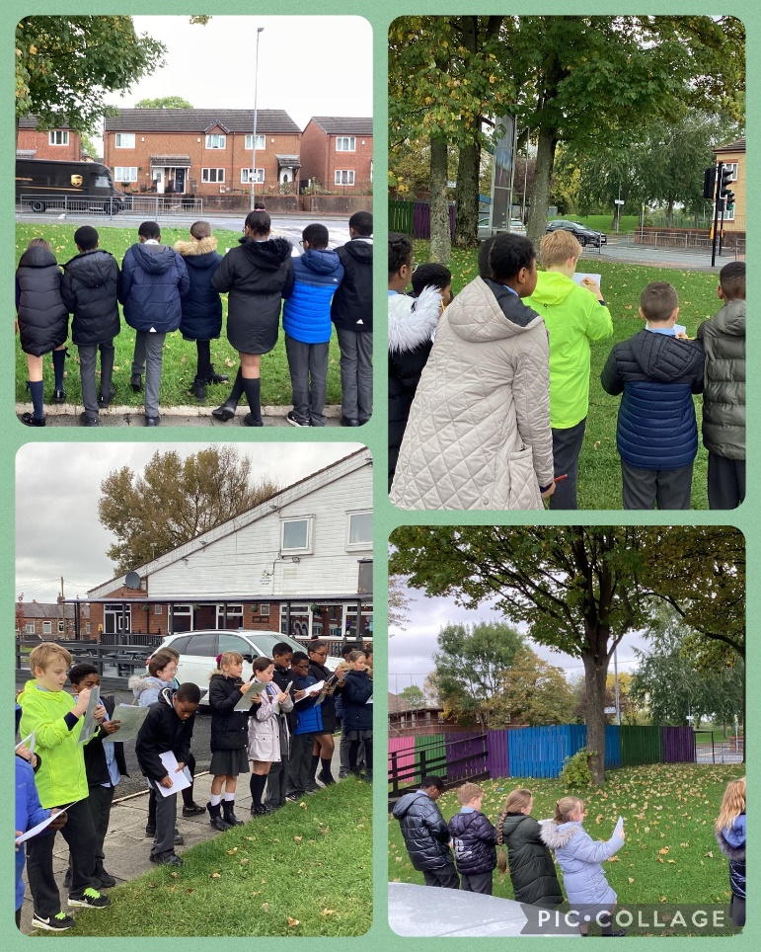

Author Visit – Kate Milner
Year 3, 5 and 6 had a fantastic day with Kate Milner learning about how she created My Name Is Not Refugee and having a go at our own illustrations. She helped us to think about the challenged many refugees face and how she uses her illustrated to depict the emotions of the characters. We also got to ask her questions about being an author.
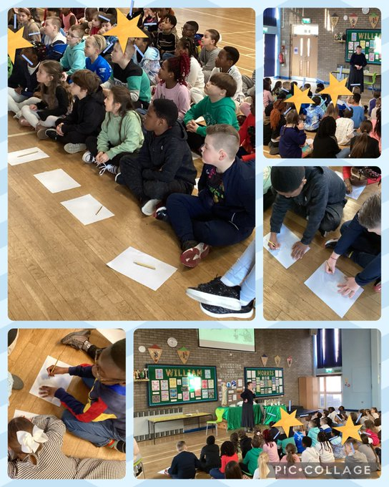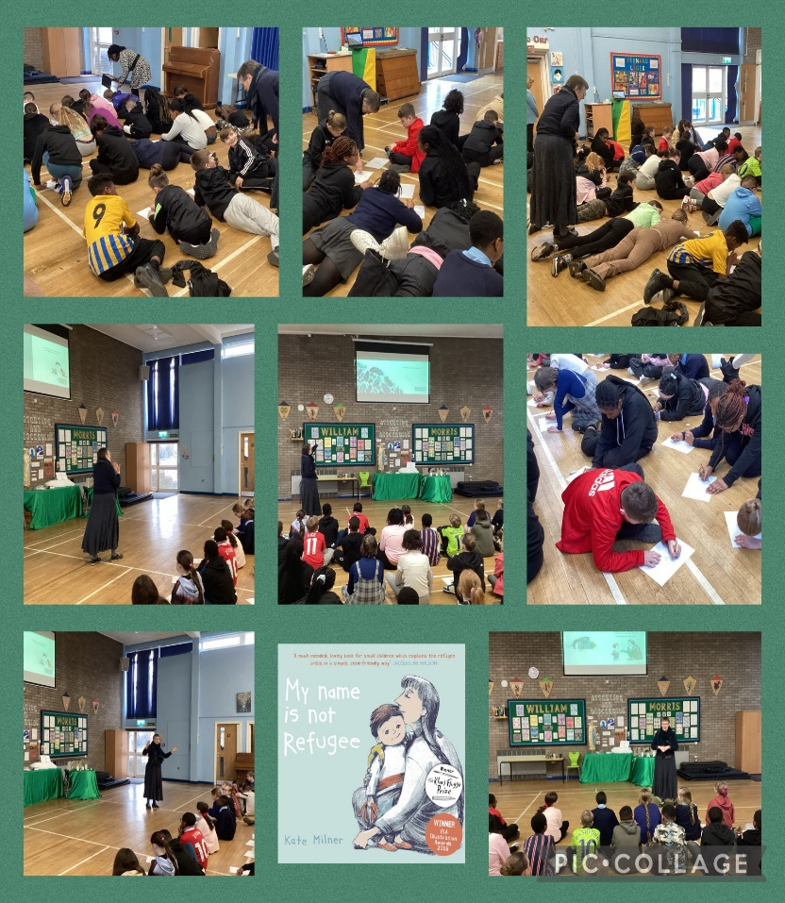

World Book Day – L.D Lapinski
We had a special visitor for World Book Day. L.D Lapinski, one of the very special World Book Day authors, talked to the children about their brilliant books ‘The Strange Worlds Travel Agency’. We got to ask them lots of questions all about inspiration, how to write a captivating book, and how to become a world famous author. We all received a copy of their book.
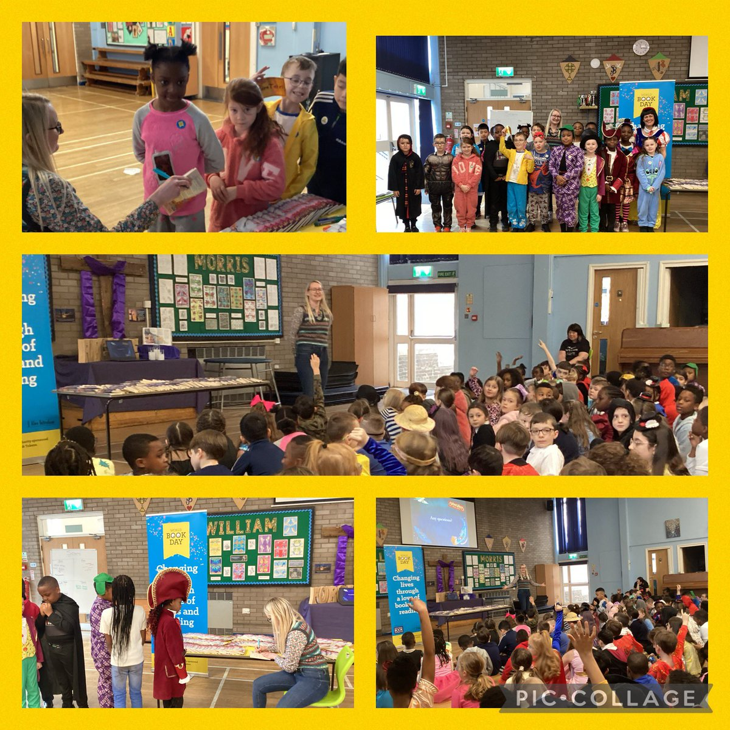

Aspirations Week
During Aspirations Week, we have been talking to the children about aspirational people and different jobs. Four special visitors came to school to tell us about their jobs and we had the opportunity to ask lots of questions. We found out about careers in IT, Architecture, Mental Health & Well-being and as a trainee Funeral Director.
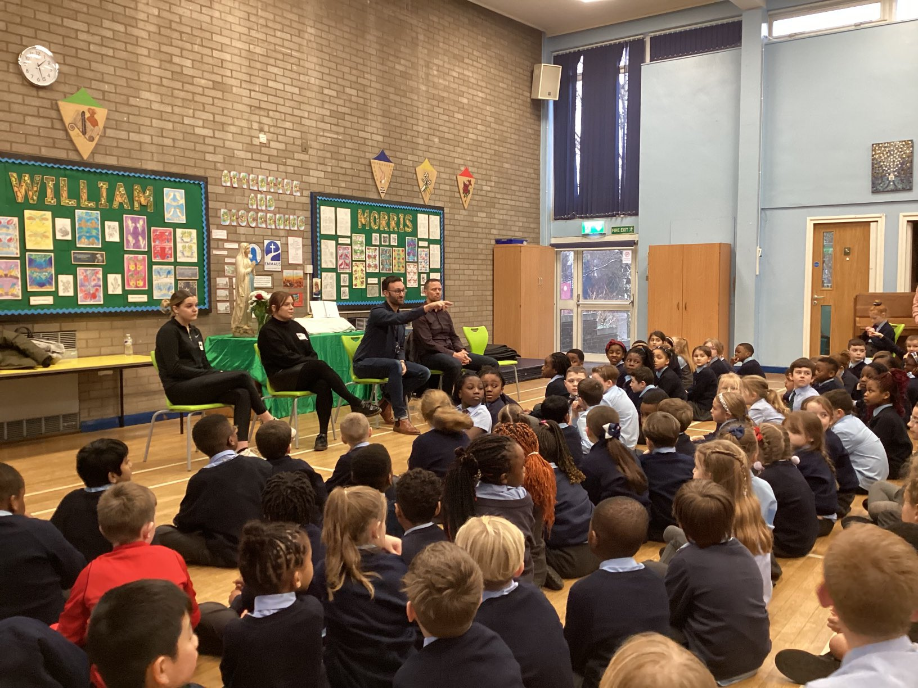

After School Clubs
Computing
Year 5 and 6 practiced their programming and coding skills on Scratch on the iPad.
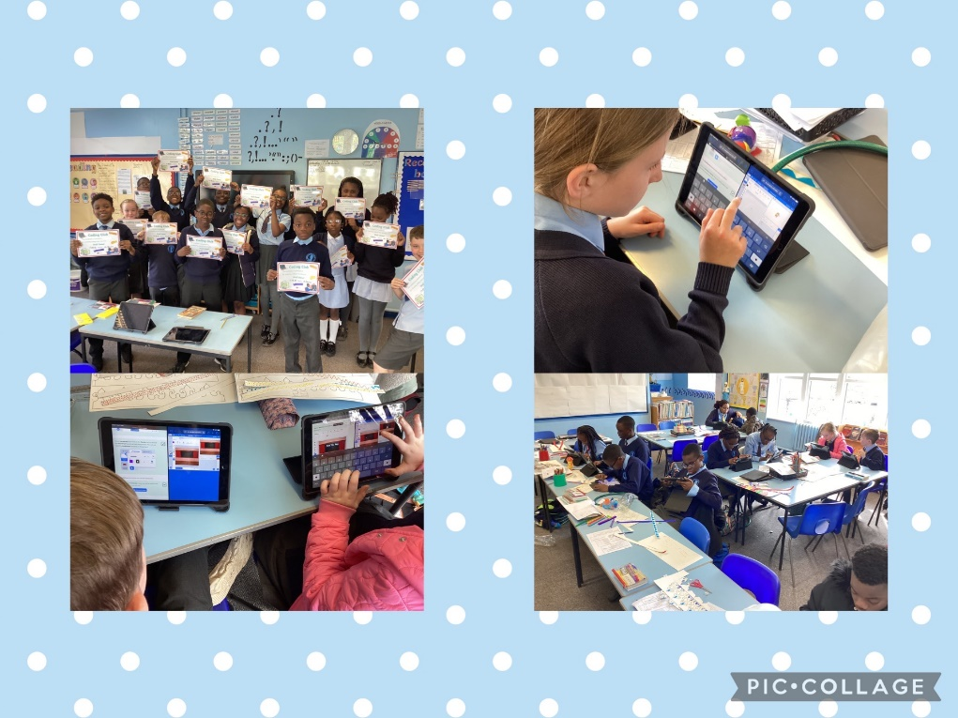
Art
Year 5 and 6 had a great half term practicing their art skills. They used many different art resources to create some beautiful art work. We have some amazing artists at Mount Carmel.