12/06/2023

Dear Parents and Carers,

The weather this week is to be very hot, outside of the normal summer temperatures that we have in this part of the world. School will, of course, be open as usual but we will be trying to keep everyone as cool as possible.

Please make sure that the children come to school ready for a hot day:

- with a sunhat and with sun cream already applied. (We cannot apply it in school but children may apply their own if they can.)
- no jumpers or coats
- water bottles, perhaps with ice (we can refill water as much as they need)
- open necked shirts (no ties)
- shirts can be untucked and loose

We will try to give the children outside time as the school will be warm inside, but we will be mindful of not letting them stay out in the sun for too long. We don’t have many shady spots but we will use all the ones we can find and will keep running around to a minimum.

Normally we love it when the sun comes out but the forecast is for weather that we are just not used to having, so we will be careful.

Best wishes,

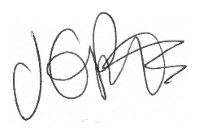

Jacqui Potts

