14/02/2023

Dear Parents and Carers,

As you may know, our governing board and our children have been taking part in a recruitment process to find our next Headteacher. (Some of our children from Y5 were part of the interview panel.)

So, on behalf of our governing board, I am delighted to announce that, after a gruelling day of tasks and interviews, Mrs Seaborn has been successful and will become Headteacher of Mount Carmel RC Primary in September.

She will be an incredible Headteacher as she already has the best for our children at the heart of everything she does. I will be working closely with her over the second half of the year to ensure that we have a smooth transition.

I am sure that you will want to join me in congratulating her and wishing her every success in her new role.

Thank you all for your support,

Best wishes,

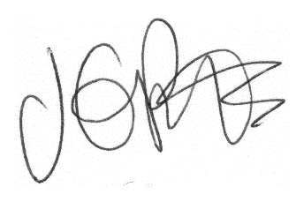

Jacqui Potts
(On behalf of the Governing Board)

