Thursday 5th January, 2023

Dear Parent/Carer,

Now that we are at the beginning of a new school term, we feel it necessary to remind parent/carers about the start time for school at the Infant Department.

It is so unsettling for a child to arrive late into their classroom after the lesson has started and it is not the best way for them to start the day. It also means that Mrs Clancy is taken from her normal duties to ensure the children get to their classes safely.

School start time at the Infant Department is 8.50a.m. The gates open at 8.40a.m.

We do understand that there may be occasions when there might be a delay getting your child to school on time, however, these should be a rare event.

We thank you for your understanding with this. If there is any reason why you are unable to get your child in to school on time, moving forward, please contact Mrs Potts or speak to a member of the office staff.

Yours sincerely

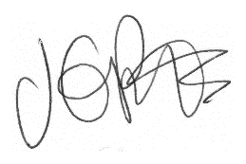

J. Potts
Head Teacher

